A PROJECT REPORT  
on

“Nova Wellness: Elevating Women's Health and Embracing Holistic Vitality”

Submitted to

**KIIT Deemed to be University**

In Partial Fulfillment of Requirement for the Award of

BACHELORS DEGREE IN

COMPUTER SCIENCE ENGINEERING

BY

AISHWARYA BASU(2005563)

HARSHITA SINGH (2005580)

INDRANI SARKAR(2005581)

RITISHA NANDA (2005602)

SUPRAVA SAMAL (2005622)

REETIKA SAMANTRA (20051660)

Under the Guidance of

Prof. Ajit Kumar Pasayat

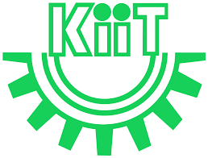

SCHOOL OF COMPUTER ENGINEERING

KALINGA INSTITUTE OF INDUSTRIAL TECHNOLOGY

BHUBANESWAR, ODISHA - 751024

April 2024

**KIIT Deemed to be University**

SCHOOL OF COMPUTER ENGINEERING

BHUBANESWAR, ODISHA - 751024



CERTIFICATE

This is to certify that the project entitled

“Nova Wellness: Elevating Women's Health and Embracing Holistic Vitality”

Submitted by

Aishwarya Basu(2005563)

Harshita Singh (2005580)

Indrani Sarkar(2005581)

Ritisha Nanda (2005602)

Suprava Samal (2005622)

Reetika Samantra (20051660)

This is a record of bonafide work carried out by them, in the partial fulfillment of the requirement for the award of Degree of Bachelor of Engineering (Computer Science & Engineering OR Information Technology) at KIIT Deemed to be university, Bhubaneswar. This work is done during the year 2023-2024, under our guidance.

Date : 25/4/2024

Prof. Ajit Kumar Pasayat

(Project Guide)

**ACKNOWLEDGEMENT**

We extend profound gratitude to Prof. Ajit Kumar Pasayat, of School of Computer Science Engineering, KIIT University, for his steadfast dedication and advocacy in the realm of women's health and empowerment. His visionary leadership and commitment to understanding and promoting menstrual wellbeing have been pivotal in inspiring the inception of Nova Wellness.

We deeply appreciate his guidance, support, and encouragement throughout the journey of developing this groundbreaking project. Prof. Ajit Kumar Pasayat's passion for reshaping the narrative surrounding women's health and fostering a vibrant, inclusive, and supportive community has served as a profound source of inspiration.

His advocacy has not only catalyzed the establishment of Nova Wellness but has also laid the groundwork for our mission to empower women with comprehensive, accurate, and empowering information. His belief in the significance of open dialogue, challenging stigmas, and prioritizing women's health and wellbeing has profoundly influenced the core values of Nova Wellness.

We owe a debt of gratitude to Prof. Ajit Kumar Pasayat for his invaluable insights, expertise, and unwavering commitment to advancing women's health globally. His tireless efforts have illuminated the prevalence, impact, and disparities of women's health issues, propelling us toward our shared vision of fostering a healthier, more equitable, and inclusive future for all women.

In recognition of his remarkable contributions, we proudly dedicate Nova Wellness: Elevating Women's Health and Embracing Holistic Vitality to Prof. Ajit Kumar Pasayat, whose passion and advocacy continue to inspire us every day. Additionally, we extend our gratitude to our families for the knowledge and connections they have generously provided.

Aishwarya Basu(2005563)

Harshita Singh (2005580)

Indrani Sarkar(2005581)

Ritisha Nanda (2005602)

Suprava Samal (2005622)

Reetika Samantra (20051660)

**ABSTRACT**

"Nova Wellness: Elevating Women's Health and Embracing Holistic Vitality" is a pioneering project designed to address the multifaceted domain of women's health, encompassing its unique medical, biological, cultural, and social factors. This comprehensive initiative offers an in-depth exploration of common women's health concerns, including menstrual wellbeing, reproductive health, mental health, sexual health, women-related cancers, and chronic conditions. By emphasizing the importance of holistic wellness and personalized care approaches, Nova Wellness aims to empower women to prioritize their health and wellbeing across various life stages and transitions.

The project leverages key statistics and insights to shed light on the prevalence, impact, and disparities of women's health issues on a global scale. It also addresses the profound influence of cultural and social factors on women's health experiences, perceptions, and interactions with healthcare systems and providers. Nova Wellness fosters awareness, education, empowerment, and interdisciplinary collaboration to advance women's health, reduce disparities, and improve health outcomes and quality of life for women worldwide. Through a diverse range of resources, including informative articles, community platforms, mental health checks, and collaborative partnerships with healthcare professionals, experts, and organizations, Nova Wellness aims to redefine the narrative surrounding women's health. By providing a trusted, comprehensive, and user-friendly online platform, Nova Wellness aspires to be a beacon of support, guidance, and inspiration for women, fostering a vibrant, inclusive, and supportive community where every woman feels valued, heard, and empowered to advocate for her health and wellbeing.

Nova Wellness is dedicated to empowering women with comprehensive, accurate, and empowering information, fostering open dialogue, challenging stigmas, and building a vibrant, inclusive, and supportive community where every woman feels valued, heard, and empowered to prioritize and advocate for her health and wellbeing, thereby contributing to a healthier, more equitable, and inclusive future for all women globally.

**Keywords:** Women's Health, Menstrual Wellbeing, Reproductive Health, Mental Health, Chronic Conditions, Women-related Cancers, Holistic Wellness, Personalized Care, Awareness, Education, Empowerment, Mental Health Checks, Informative Articles, Global Health.

**TABLE OF CONTENTS**

|  |  |  |  |  |
| --- | --- | --- | --- | --- |
| Sl. No | Heading | | | Pg No. |
| 1 | Introduction | | | 1-2 |
| 2 | Background and Objectives | | | 3-6 |
| 3 | Literature Review | | | 7-11 |
| 4 | About Women’s Health | | | 12-16 |
| 5 | Need and Purpose | | | 17-20 |
| 6 | Nova Welllness Website Overview | | | 21-43 |
|  | 6.1 | Nova Wellness-Home | | 22-23 |
|  | 6.2 | Nova Wellness-Community | | 24-29 |
|  | 6.3 | Nova Wellness-About Us | | 30-32 |
|  | 6.4 | Nova Wellness-Learn Center | | 33-38 |
|  |  | 6.4.1 | Nova Blogging | 36-37 |
|  | 6.5 | Nova Wellness-Mental Health Check | | 38-41 |
|  | 6.6 | Nova Wellness- Social Media Engagement | | 42 |
| 7 | Technologies Used | | | 44-49 |
|  | 7.1 | Front-end Techologies | | 44-45 |
|  | 7.2 | Back-end Technologies | | 45-46 |
|  | 7.3 | Database | | 46-47 |
|  | 7.4 | Security Measures | | 48 |
| 8 | Content Strategy | | | 50-53 |
| 9 | Challlenges and Solutions | | | 54-56 |
| 10 | Women’s Wellness and Lifestyle | | | 57-60 |
| 11 | Conclusion | | | 61-62 |
| 12 | Future Scope and Enhancements | | | 63-65 |
| References | | | | 66 |
| Individual Contribution | | | | 67-72 |
| Plagiarisn Report | | | | 73 |

1

CHAPTER 1

INTRODUCTION

**________________________________________________**

Nova Wellness is a pioneering platform designed with a unique vision: to elevate women's health and embrace holistic vitality. As a website built by women for women, Nova Wellness is dedicated to providing comprehensive, accurate, and empowering information tailored to meet the diverse health and wellness needs of women across the globe.

In today's rapidly evolving digital landscape, access to reliable and personalized health information is crucial. Women often face challenges in finding credible resources that address their specific health concerns and needs. Recognizing this gap, Nova Wellness aims to be a trusted ally for women, offering a wide range of resources, insights, and support to help them make informed decisions about their health and wellbeing.

Our platform covers a broad spectrum of topics, including menstrual wellbeing, reproductive health, physical fitness, mental wellness, nutrition, and lifestyle. We believe in the importance of a holistic approach to health, considering not only the physical but also the emotional and mental aspects of wellness. Through our curated content, expert insights, and user-friendly interface, we strive to empower women to take control of their health, embrace self-care, and live their lives to the fullest.

At Nova Wellness, we understand that every woman's journey is unique, shaped by individual experiences, backgrounds, and lifestyles. That's why our platform is designed to be inclusive and adaptable, catering to the diverse needs and preferences of women from all walks of life. Whether you're a young adult navigating the transitions of puberty and early adulthood, a busy professional juggling work and family responsibilities, or an older woman embracing the challenges and opportunities of menopause and beyond, Nova Wellness is here to support you at every stage of your life.

2

Beyond just information, Nova Wellness is also a community. We encourage women to share their experiences, stories, and insights, fostering a supportive and inclusive environment where women can connect, learn from each other, and celebrate their unique journeys. Our community platform, Nova Community, serves as a hub for women to engage, discuss, and support each other through shared experiences and collective wisdom.

In addition to our main platform, Nova Blogging serves as an extension of our commitment to women's health and empowerment. It features in-depth articles relevant to women's health and wellness. Whether you're navigating the challenges of menstrual health, exploring new fitness routines, or seeking advice on mental wellbeing, Nova Blogging offers valuable insights and guidance to support you every step of the way.

Nova Wellness is committed to empowering women with comprehensive and reliable health resources. Through a holistic approach and community support, we aim to inspire women to take control of their health and well-being, fostering a world where health and wellness are accessible and celebrated by all.

At Nova Wellness, our mission transcends beyond merely providing information; it is about creating a movement. A movement where every woman feels empowered, informed, and supported in her health and wellness journey. We are committed to breaking down barriers, challenging stigmas, and fostering a global community of empowered women who prioritize their health, embrace self-care, and advocate for holistic vitality. Our unwavering dedication to excellence, inclusivity, and community engagement drives us to continuously evolve, innovate, and elevate the standards of women's healthcare information and support services.

As we embark on this transformative journey towards a world where health, wellness, and holistic vitality are accessible, celebrated, and embraced by all, we invite you to join us. Together, we can redefine the narrative surrounding women's health, inspire positive change, and build a brighter, healthier, and more empowered future for women everywhere. With Nova Wellness, every woman's health journey is celebrated, supported, and empowered.

3

CHAPTER 2

BACKGROUND

AND OBJECTIVES

**________________________________________________**

As we navigate the complexities of women's health in today's digital age, the significance of accessible, accurate, and empowering healthcare information and support services becomes increasingly paramount. Women's health and well-being encompass a myriad of interconnected facets, each requiring nuanced understanding, tailored resources, and a compassionate approach to ensure holistic vitality and empowerment.

Against this backdrop, Nova Wellness was conceived with a visionary mission to revolutionize the landscape of women's healthcare information and support services. Through a profound understanding of the prevailing challenges, disparities, and societal stigmas surrounding women's health issues, Nova Wellness is committed to empowering women, fostering holistic well-being, challenging stigmas, and building an inclusive and supportive community where every woman feels valued, heard, and empowered to prioritize and advocate for her health and well-being. This section delves deeper into the background and objectives that shape and drive the mission and vision of Nova Wellness.

**2.1 BACKGROUND**

In the intricate tapestry of women's health, a profound realization has emerged, illuminating the significant gaps, challenges, and disparities that women encounter in their quest for reliable, comprehensive, and personalized health information and resources tailored to their unique needs, experiences, and circumstances. In the digital age, characterized by an overwhelming abundance of health information available online, women often find themselves navigating a labyrinth of misinformation, biased narratives, and inadequate resources that fail to address their specific health concerns and holistic well-being, exacerbating feelings of confusion, uncertainty, and disillusionment.

4

Beyond the complexities of accessing accurate and tailored health information, women grapple with deep-rooted societal stigmas, cultural taboos, and gender biases surrounding women's health issues, particularly menstrual well-being, reproductive health, mental wellness, sexual health, menopause, and other sensitive and intimate aspects of women's health and well-being. These pervasive taboos and biases have perpetuated a culture of silence, shame, and misunderstanding, creating formidable barriers to open dialogue, awareness, education, and support.

The stigma surrounding menstrual health and menstruation, often shrouded in myths, misconceptions, and cultural taboos, has marginalized discussions and awareness around menstrual hygiene, menstrual disorders, and the broader menstrual cycle, hindering access to essential information, resources, and support. Similarly, reproductive health concerns, including fertility, contraception, pregnancy, and childbirth, are often surrounded by societal stigmas, misinformation, and inadequate education, leading to misconceptions, anxiety, and barriers to accessing quality healthcare services and support.

Mental wellness, encompassing emotional, psychological, and cognitive well-being, is another critical area where women face significant challenges due to pervasive stigmas, gender biases, and societal expectations. Mental health issues, including anxiety, depression, mood disorders, postpartum depression, and trauma, are often stigmatized, misunderstood, and overlooked, resulting in limited access to mental health resources, support, and compassionate care.

Furthermore, sexual health, a vital component of women's overall health and well-being, is often shrouded in secrecy, shame, and misinformation due to cultural taboos, societal norms, and inadequate sexual education and awareness. These barriers and challenges have contributed to a lack of awareness, limited access to sexual health resources and services, and barriers to open and honest communication about sexual health, relationships, and intimacy, leaving many women feeling isolated, uninformed, and unsupported in their sexual health journey.

Recognizing the profound impact of these prevailing challenges, disparities, and taboos on women's health and well-being, Nova Wellness was conceptualized with a visionary and compassionate approach to bridge the existing gaps, challenge the status quo, and revolutionize the landscape of women's healthcare information and support services. As a platform passionately dedicated to elevating women's health, dismantling taboos, and embracing holistic

5

vitality, Nova Wellness is committed to empowering women with accurate, evidence-based, and empowering information, fostering open dialogue, challenging stigmas and misconceptions, and building a vibrant, inclusive, and supportive community where every woman feels valued, heard, and empowered to prioritize and advocate for her health, well-being, and holistic vitality.

**2.2 OBJECTIVES**

The primary objectives of Nova Wellness are multifaceted, aiming to revolutionize the way women access, perceive, and engage with healthcare information and support services. Rooted in our unwavering commitment to empowering women, fostering holistic well-being, and challenging societal norms and barriers that inhibit women's health and wellness, our objectives are designed to address the multifaceted challenges, disparities, and taboos surrounding women's health and well-being.

* Comprehensive Information Hub: To establish Nova Wellness as a trusted, comprehensive, and user-friendly online platform that offers a diverse range of reliable, accurate, and evidence-based information on various aspects of women's health, including menstrual wellbeing, reproductive health, mental wellness, physical fitness, nutrition, lifestyle, menopause, and other critical and sensitive aspects of women's health and well-being.
* Empowerment Through Education: To empower women with knowledge, resources, and tools to make informed decisions about their health and well-being, enabling them to take proactive steps, embrace self-care, advocate for their health, and navigate their health journey with confidence, clarity, resilience, and empowerment.
* Community Engagement and Support: To cultivate a vibrant, inclusive, and supportive community through our community platform, Nova Community, where women can connect, share experiences, stories, insights, and support each other through shared experiences, collective wisdom, mutual encouragement, and compassionate support, transcending geographical, cultural, and socio-economic barriers.

6

* Challenge Stigmas and Foster Open Dialogue: To challenge and dismantle societal stigmas, cultural taboos, gender biases, and misconceptions surrounding women's health issues, particularly menstrual wellbeing, reproductive health, mental wellness, sexual health, and other sensitive and intimate aspects of women's health, by fostering open dialogue, raising awareness, promoting positive, empowering, inclusive, and destigmatized narratives, and encouraging honest, respectful, and compassionate conversations.
* Inclusivity and Accessibility: To ensure that Nova Wellness is inclusive, accessible, and equitable to women from all walks of life, catering to the diverse needs, backgrounds, preferences, and experiences of women globally, and transcending geographical, cultural, socio-economic, linguistic, and accessibility barriers by offering multilingual content, accessible design, and tailored resources to meet the unique needs and circumstances of every woman.
* Continuous Innovation and Collaboration: To continuously innovate, evolve, and enhance our platform, content, and services by collaborating with healthcare professionals, experts, researchers, organizations, and community members to ensure the credibility, relevance, effectiveness, and inclusivity of our content, resources, support services, and community engagement initiatives, fostering a culture of continuous learning, improvement, and excellence.

By diligently pursuing these objectives, Nova Wellness aspires to redefine the narrative surrounding women's health, inspire positive change, dismantle barriers, challenge stigmas and taboos, build a brighter, healthier, and more empowered future for women everywhere, and create a world where health, wellness, and holistic vitality are celebrated, accessible, embraced, and prioritized by all.

7

CHAPTER 3

LITERATURE REVIEW

**________________________________________________**

The literature review delves into the intricate landscape of women's health and wellbeing, tracing its evolution from historical misconceptions and taboos to the contemporary challenges and advancements. Over the recent past, women's health has undergone a transformative journey, breaking through age-old myths, societal barriers, and gender biases to emerge as a pivotal domain of healthcare, research, and advocacy. Despite significant progress, women continue to face multifaceted challenges, disparities, and stigmas surrounding menstrual wellbeing, mental health, sexual health, women-related cancers, and holistic wellness. This literature review provides a comprehensive overview of the existing research, studies, and information related to these critical aspects of women's health and wellbeing, shedding light on the prevailing issues, advancements, and opportunities for enhancing women's health, empowerment, and holistic wellbeing.

**3.1 Women's Health: An Overview**

Women's health encompasses a broad range of physical, emotional, mental, and social aspects that are unique to women's experiences and needs. The World Health Organization (WHO) defines women's health as a state of complete physical, mental, and social well-being and not merely the absence of disease or infirmity. Historically, women's health has been marginalized, leading to disparities in access to healthcare, research, and resources tailored to women's specific needs and concerns. Recent advancements in healthcare, awareness, and advocacy have contributed to a greater understanding and recognition of the importance of prioritizing women's health and well-being.

Global Women's Health Statistics: According to the World Health Organization (WHO), women comprise more than half of the global population and face unique health challenges, including maternal mortality, reproductive health issues, gender-based violence, and non-communicable diseases.

8

Barriers to Women's Healthcare: Despite advancements in healthcare, women face numerous barriers to accessing quality healthcare services, including cultural, societal, economic, and systemic barriers, leading to disparities in health outcomes and access to care.

**3.2 Menstrual Wellbeing**

Menstrual wellbeing is a critical aspect of women's health and well-being, encompassing the physical, emotional, and social aspects of the menstrual cycle. Menstrual wellbeing is often influenced by various factors, including hormonal changes, lifestyle, nutrition, stress, and underlying health conditions.

Menstrual Disorders and Impact: According to the American College of Obstetricians and Gynecologists (ACOG), menstrual disorders, including menstrual irregularities, premenstrual syndrome (PMS), and menstrual pain (dysmenorrhea), affect millions of women worldwide, impacting their quality of life, productivity, and overall well-being.

Stigma and Misconceptions: Menstrual wellbeing is often surrounded by stigma, misconceptions, and cultural taboos, leading to silence, shame, and barriers to open dialogue, education, and support.

**3.3 Mental Health and Women**

Mental health is a critical component of women's overall health and well-being, encompassing emotional, psychological, and cognitive aspects. Women are more susceptible to mental health issues, including anxiety, depression, mood disorders, postpartum depression, and trauma, due to various factors, including hormonal fluctuations, biological factors, life experiences, societal pressures, and gender-specific challenges.

Global Mental Health Statistics: According to the World Health Organization (WHO), women are disproportionately affected by mental health issues, with depression being the leading cause of disability among women globally.

9

Barriers to Mental Health Care: Despite the high prevalence and impact of mental health issues on women's lives, there is a significant stigma, lack of awareness, and barriers to accessing mental health resources, support, and compassionate care, highlighting the need for comprehensive, accessible, and women-centered mental health services and initiatives.

**3.4 Sexual Health and Wellness**

Sexual health is an integral component of women's overall health and well-being, encompassing physical, emotional, and social aspects of sexual well-being and relationships. Sexual health is influenced by various factors, including biological factors, hormonal changes, life experiences, relationships, societal attitudes, and cultural beliefs.

Global Sexual Health Statistics: According to the World Health Organization (WHO), sexual and reproductive health issues, including unintended pregnancies, sexually transmitted infections (STIs), and gender-based violence, are significant public health concerns affecting millions of women worldwide.

Barriers to Sexual Health Care: Despite the importance of sexual health and its impact on women's quality of life, relationships, and overall well-being, there is a lack of awareness, education, and open dialogue about sexual health issues, concerns, and needs, leading to stigma, misconceptions, and barriers to accessing sexual health resources, support, and inclusive and affirming sexual healthcare services.

**3.5 Women-Related Cancers**

Women-related cancers, including breast cancer, cervical cancer, ovarian cancer, uterine cancer, and other gynecological cancers, are significant public health concerns and leading causes of cancer-related morbidity and mortality among women globally.

Global Cancer Statistics: According to the World Health Organization (WHO), breast cancer is the most common cancer among women worldwide, with cervical cancer being a leading cause of cancer-related deaths among women in low- and middle-income countries.

10

Early Detection and Screening: Early detection, timely diagnosis, and effective treatment are crucial for improving outcomes, reducing mortality, and enhancing the quality of life for women diagnosed with cancer.

**3.6 Holistic Wellness for Women**

Holistic wellness for women emphasizes the importance of addressing the interconnected physical, emotional, mental, spiritual, and social aspects of women's health and well-being. Holistic wellness approaches focus on promoting balance, harmony, and integration of the mind, body, and spirit through personalized, comprehensive, and integrative health and wellness strategies.

Global Wellness Trends: According to the Global Wellness Institute, there is a growing interest and recognition of the importance of holistic wellness approaches for promoting women's health and well-being, with women increasingly seeking personalized, integrative, and holistic health and wellness services and resources to enhance their overall well-being.

Barriers to Holistic Wellness: Despite the growing interest and recognition of the importance of holistic wellness approaches for promoting women's health and well-being, there is a need for further research, education, accessibility, and affordability of holistic wellness resources, services, and supportive networks to empower women to prioritize and enhance their holistic wellness.

**3.7 Women's Health Research and Studies**

Women's health research and studies play a crucial role in advancing the understanding, knowledge, and evidence-based practices related to women's health and well-being.

Representation in Research: Despite advancements in women's health research, there are gaps, disparities, and limitations in the representation, inclusion, and prioritization of women in research, leading to biases, misconceptions, and inadequate evidence to guide women-centered care and practices.

11

Advancing Women's Health Research: Enhancing women's representation, participation, and prioritization in research, fostering collaborative and interdisciplinary research approaches, and promoting the translation, dissemination, and implementation of research findings into clinical practice, policies, and programs are essential for advancing women's health, addressing disparities, and improving health outcomes and quality of life for women globally.

This literature review illuminates the intricate landscape of women's health and wellbeing, highlighting the multifaceted challenges, disparities, and stigmas that persist despite advancements in healthcare, research, and advocacy. It underscores the critical importance of adopting comprehensive, inclusive, and women-centered approaches to healthcare, research, and support to address the unique and diverse needs of women across the globe. Despite the progress made, barriers and stigmas continue to hinder access to quality healthcare, information, and support, emphasizing the urgent need for enhanced awareness, education, empowerment, and collaborative efforts to overcome these challenges and improve health outcomes, access to care, and quality of life for women globally.

Nova Wellness aims to bridge the existing gaps and revolutionize the landscape of women's healthcare information and support services. Through our platform and initiatives, we strive to empower women with accurate, evidence-based, and empowering information, foster open dialogue, challenge stigmas, and build a vibrant, inclusive, and supportive community where every woman feels valued, heard, and empowered to prioritize and advocate for her health and wellbeing, inspiring positive change, and building a brighter, healthier, and more empowered future for women everywhere.

12

CHAPTER 4

ABOUT WOMEN’S HEALTH

**________________________________________________**

Understanding women's health is crucial to addressing the unique and multifaceted needs, concerns, and challenges that women encounter throughout their lives. This comprehensive section delves into the medical aspects of women's health, exploring common concerns, the significance of holistic wellness, pivotal statistics, and the profound influence of cultural and social factors on women's health and wellbeing.

**4.1 Understanding Women's Health**

Women's health is a complex and multifaceted domain that encompasses a wide range of physical, emotional, mental, and social factors. It is shaped by a myriad of medical and biological factors, including:

Biological Differences: Women's physiology and anatomy differ from men's, influencing their health needs and vulnerabilities. For instance, hormonal fluctuations during menstruation, pregnancy, childbirth, and menopause can impact women's health and wellbeing.

Hormonal Changes: Hormonal imbalances can lead to various health issues, such as polycystic ovary syndrome (PCOS), endometriosis, menstrual irregularities, infertility, and hormonal cancers.

Life Stages: Different life stages, such as puberty, reproductive years, pregnancy, postpartum, perimenopause, and menopause, bring unique health challenges and concerns for women.

A comprehensive understanding of women's health requires recognizing and addressing these interconnected medical and biological factors, promoting holistic approaches to care that foster physical health, emotional wellbeing, mental resilience, and social support.

13

**4.2 Common Women's Health Concerns**

Throughout their lives, women grapple with a diverse range of common health concerns and medical conditions, such as:

Menstrual Wellbeing: Menstrual disorders, including menstrual irregularities, premenstrual syndrome (PMS), dysmenorrhea (menstrual pain), and menorrhagia (heavy menstrual bleeding), are common concerns affecting women's reproductive health and quality of life.

Reproductive Health: Reproductive issues, such as infertility, polycystic ovary syndrome (PCOS), endometriosis, uterine fibroids, ovarian cysts, pelvic inflammatory disease (PID), and sexually transmitted infections (STIs), are significant health concerns affecting women's reproductive health and fertility.

Mental Health: Women are more susceptible to mental health issues, including anxiety disorders, depression, postpartum depression, mood disorders, eating disorders, and self-harm, due to hormonal fluctuations, biological factors, life experiences, societal pressures, and gender-specific challenges.

Sexual Health: Sexual health issues, such as sexual dysfunction, low libido, pelvic pain, vaginal infections, and sexually transmitted infections (STIs), can impact women's sexual wellbeing, relationships, and quality of life.

Women-Related Cancers: Women-related cancers, including breast cancer, cervical cancer, ovarian cancer, uterine cancer, and other gynecological cancers, are significant public health concerns and leading causes of cancer-related morbidity and mortality among women globally.

Cardiovascular Health: Cardiovascular diseases, including heart disease, stroke, and hypertension, are leading causes of morbidity and mortality among women worldwide, often underdiagnosed and undertreated due to gender biases, atypical symptoms, and lack of awareness.

14

Osteoporosis and Bone Health: Osteoporosis, a bone disease characterized by low bone mass and deterioration of bone tissue, is a significant health concern affecting women, particularly postmenopausal women, increasing the risk of fractures and mobility issues.

Autoimmune Diseases: Autoimmune diseases, such as rheumatoid arthritis, lupus, multiple sclerosis, and thyroid disorders, are more prevalent in women, affecting the immune system and various organs and tissues, leading to chronic pain, fatigue, disability, and reduced quality of life.

Chronic Conditions: Chronic conditions, such as diabetes, obesity, metabolic syndrome, respiratory diseases, and gastrointestinal disorders, are common health concerns affecting women's health, wellbeing, and quality of life.

Understanding, identifying, diagnosing, treating, managing, and preventing these common health concerns and medical conditions are essential for promoting women's health, wellbeing, and quality of life, fostering awareness, education, prevention, early detection, diagnosis, treatment, support, and empowerment to enhance health outcomes and holistic wellbeing across the lifespan.

**4.3 The Importance of Holistic Wellness**

Holistic wellness emphasizes the significance of addressing and integrating the interconnected physical, emotional, mental, spiritual, and social dimensions of women's health and wellbeing. It focuses on promoting balance, harmony, and integration of the mind, body, and spirit through personalized, comprehensive, and integrative health and wellness strategies. Holistic wellness approaches foster self-awareness, self-care, self-empowerment, resilience, and self-advocacy, encouraging women to prioritize their health, wellbeing, and quality of life by embracing holistic approaches to care that nurture and support their overall health and wellbeing across the lifespan.

**4.4 Women's Health Statistics**

Key statistics and trends related to women's health provide critical insights into the prevalence, impact, and disparities of women's health issues and concerns. According to the World Health Organization (WHO) and other leading health organizations:

15

* Women comprise more than half of the global population and face unique health challenges, including maternal mortality, reproductive health issues, gender-based violence, non-communicable diseases, mental health issues, and barriers to accessing quality healthcare services.
* Women are disproportionately affected by mental health issues, with depression being the leading cause of disability among women globally.
* Breast cancer is the most common cancer among women worldwide, with cervical cancer being a leading cause of cancer-related deaths among women in low- and middle-income countries.

Despite advancements in healthcare, research, and advocacy, women continue to face barriers, disparities, and stigmas surrounding menstrual wellbeing, mental health, sexual health, women-related cancers, and holistic wellness.

**4.5 Cultural and Social Factors**

Cultural and social factors play a pivotal role in shaping women's health beliefs, attitudes, behaviors, access to healthcare, and health outcomes. Cultural norms, beliefs, practices, taboos, gender roles, societal attitudes, discrimination, and inequalities significantly influence women's health experiences, perceptions, and interactions with healthcare systems and providers. These factors can impact women's health-seeking behaviors, decision-making, access to healthcare, quality of care, treatment outcomes, and overall health and wellbeing.

* Cultural beliefs and taboos surrounding women's health issues, such as menstrual wellbeing, reproductive health, sexual health, and women-related cancers, can lead to silence, shame, and barriers to open dialogue, education, and support, hindering awareness, early detection, diagnosis, treatment, and support.
* Gender roles, societal attitudes, discrimination, and inequalities can contribute to women's vulnerability to gender-based violence, reproductive rights violations, sexual health issues, mental health issues, and barriers to accessing quality healthcare services, information, resources, and support.

16

Addressing and challenging cultural and social factors, promoting cultural sensitivity, inclusivity, and diversity, fostering awareness, education, and open dialogue, empowering women, advocating for women's rights and health equity, and promoting collaborative and interdisciplinary efforts are essential for advancing women's health, addressing disparities, and improving health outcomes and quality of life for women globally.

A comprehensive understanding of women's health is vital for addressing the unique medical, biological, cultural, and social factors that influence women's wellbeing. By recognizing and addressing common health concerns, emphasizing holistic wellness, leveraging key statistics, and challenging cultural and social barriers, we can advance women's health, reduce disparities, and improve health outcomes and quality of life for women globally. Through awareness, education, empowerment, and collaborative efforts, we can work towards creating a healthier, more equitable, and inclusive future for all women.

17

CHAPTER 5

NEED AND PURPOSE

**________________________________________________**

Understanding the critical need and purpose of focusing on women's health is essential to address the unique challenges and disparities that women face across various life stages. This section aims to delve into the importance of women's health, the common health issues women encounter, bridging information gaps, empowering women through knowledge, and the public health perspective to provide a comprehensive understanding of the rationale behind the Nova Wellness project.

**5.1 The Importance of Women's Health**

Women's health is a multifaceted domain encompassing physical, mental, emotional, social, and cultural dimensions. Recognizing and prioritizing women's health is not only a matter of individual wellbeing but also a fundamental human right and a public health imperative.

Holistic Wellbeing: Women's health extends beyond reproductive and maternal health to include a wide range of issues such as cardiovascular health, bone health, mental health, and chronic conditions like diabetes and arthritis. A holistic approach that considers the interconnectedness of these aspects is crucial for promoting overall wellbeing.

Unique Challenges: Women face unique health challenges due to biological factors such as menstruation, pregnancy, and menopause, as well as social and cultural factors like gender-based violence, discrimination, and unequal access to resources and opportunities. Addressing these challenges requires tailored interventions and support systems.

Systemic Barriers: Women often encounter systemic barriers, including gender bias, lack of access to quality healthcare, and cultural stigmas, which can exacerbate health disparities and limit their ability to make informed decisions about their health.

18

Fundamental Human Right: Ensuring women's right to health and wellbeing is essential for achieving gender equality, promoting social justice, and advancing sustainable development goals. Investing in women's health is not just beneficial for women but also for families, communities, and societies at large.

**5.2 Addressing Common Women's Health Issues**

Addressing common women's health issues is crucial for improving health outcomes, enhancing quality of life, and reducing the burden of preventable diseases and conditions that disproportionately affect women.

Impactful Health Issues: Common women's health issues such as menstrual irregularities, PCOS, endometriosis, infertility, breast cancer, cervical cancer, depression, anxiety, and osteoporosis have a significant impact on physical health, emotional wellbeing, quality of life, and productivity.

Prevention and Early Detection: Prioritizing prevention, early detection, timely interventions, and personalized care is essential to improving health outcomes and reducing the burden of preventable diseases and conditions.

Evidence-Based Approaches: Developing and implementing comprehensive, evidence-based approaches that integrate innovative technologies, digital health solutions, and interdisciplinary collaboration can effectively address these common women's health issues.

**5.3 Bridging Information Gaps**

Bridging information gaps and providing women with reliable, accurate, and accessible health information is essential for empowering women to make informed decisions about their health and wellbeing.

Reliable and Accessible Information: Despite the abundance of health information available online, women often struggle to find reliable, accurate, comprehensive, and culturally sensitive information tailored to their unique health concerns, needs, and preferences.

19

Awareness and Education: Lack of awareness, misinformation, and information gaps contribute to delays in seeking care, mismanagement of health conditions, and suboptimal health outcomes.

Trusted Platforms: Bridging information gaps by providing women with access to credible, evidence-based, up-to-date, and culturally relevant health information, resources, and support services through trusted and accessible platforms like Nova Wellness is crucial.

Community Engagement: Nova Wellness fosters community engagement through its diverse range of resources, including informative articles, community platforms, mental health checks, and collaborative partnerships with healthcare professionals, experts, and organizations.

**5.4 Empowering Women Through Knowledge**

Empowering women with knowledge, skills, and resources to navigate healthcare systems effectively, engage in shared decision-making with healthcare providers, and actively participate in preventive care and self-management of health conditions is essential.

Health Literacy and Self-Advocacy: Empowering women with knowledge, skills, and resources to navigate healthcare systems effectively, engage in shared decision-making with healthcare providers, and actively participate in preventive care and self-management of health conditions is essential.

Fostering Awareness and Education: By fostering health literacy, promoting awareness, education, and self-advocacy, Nova Wellness aims to empower women to make informed decisions and advocate for their health and wellbeing.

Inclusive and Empowering Environment: Creating a supportive, inclusive, and empowering environment where every woman feels valued, heard, and empowered to prioritize and advocate for her health and wellbeing is a key objective of Nova Wellness.

Personalized Care Approaches: Nova Wellness emphasizes the importance of personalized care approaches that consider women's unique health needs, preferences, and life circumstances to improve health outcomes and quality of life.

20

**5.5 Public Health Perspective**

Promoting women's health from a public health perspective is crucial for achieving overall population health, reducing disparities, and fostering social inclusion.

Promoting Overall Population Health: Investing in women's health is crucial for promoting overall population health, achieving health equity, and advancing sustainable development goals.

Reducing Disparities: By addressing the unique and diverse health needs of women, reducing disparities, and improving access to quality healthcare services, information, and support, Nova Wellness contributes to building healthier communities and fostering social inclusion.

Transforming the Landscape of Women's Health: Through its innovative, evidence-based, and collaborative approaches, Nova Wellness aims to transform the landscape of women's health, challenge stigmas, and build a brighter, healthier, and more equitable future for all women globally.

Global Impact: Nova Wellness leverages key statistics and insights to shed light on the prevalence, impact, and disparities of women's health issues on a global scale, advocating for policy changes, and fostering international collaboration to advance women's health and wellbeing.

21

CHAPTER 6

NOVA WELLNESS

WEBSITE OVERVIEW

**________________________________________________**

**WEBSITE FEATURES AND FUNCTIONALITIES**

The Nova Wellness website is a comprehensive platform designed with a holistic approach to women's health and well-being.

**Home Page:**

The homepage offers a panoramic view of the entire website, highlighting its features and functionalities. It showcases interviews with women discussing various health factors such as menstruation, physical well-being, and more. This section also provides an overview of different segments available on the platform.

**Nova Community (Nova Community):**

The Nova Community is a vibrant social network named Nova Community, dedicated to fostering discussions on women's health topics. Users can join to share their views, post comments, like posts, and engage with a community of like-minded individuals. Here, participants can gain insights into different women's health facts, findings, and issues, promoting knowledge sharing and community building around women's health topics.

**About Us Page:**

The 'About Us' page provides an insight into the creators and visionaries behind Nova Wellness. It elaborates on the mission of the platform, which is to spread awareness and knowledge about various health issues affecting women. The page emphasizes care, wellness promotion, and the importance of acknowledging and addressing women's health concerns.

22

**Learn Center:**

The Learn Center serves as a comprehensive educational hub within Nova Wellness, focusing on key aspects of women's health. It is organized into six subcategories: Mental Health, Sexual Health, Women's Menstrual Health, Women-related Cancers, Emotional Intelligence, and Wellness and Optimal Living. Each section provides a curated collection of informative articles and frequently asked questions (FAQs) to address common health concerns and queries.

Complementing the Learn Center is Nova Blogging, a dedicated platform within the sub-website, offering in-depth articles on various women's health topics. Here, users can not only read and share valuable insights but also contribute their own articles, fostering a dynamic community of shared knowledge and experiences.

**Women Health Check:**

The Women Health Check segment offers quizzes to assess various aspects of health. These quizzes cover topics such as general health, generalized anxiety disorder, insomnia severity index, mood disorders, and more. Users can answer a set of questions, and based on their responses, the platform provides a health score, helping them understand their health condition and offering insights for potential areas of concern.

This comprehensive approach to women's well-being, combined with a user-friendly interface and engaging features, positions Nova Wellness as a go-to platform for women seeking reliable and empowering information about their health and wellness.

**6.1 Nova Wellness - Home**

The Nova Wellness website is a comprehensive platform focusing on women's health and well-being. The homepage offers an overview of the site's offerings, including interviews with women on diverse health topics. Nova Community, the Nova Community, encourages discussions and knowledge exchange on women's health, while the 'About Us' page delves into the platform's mission and creators. The Learn Center features curated articles and FAQs across six key health categories, enhanced by Nova Blogging's in-depth articles and user-contributed content. The Women Health Check provides health quizzes for self-assessment, rounding out the platform's holistic approach to empowering women with reliable information and community support for their health needs.

23

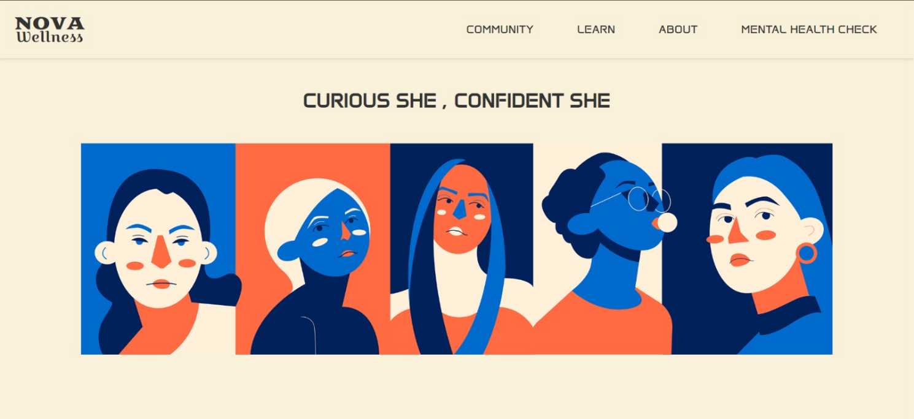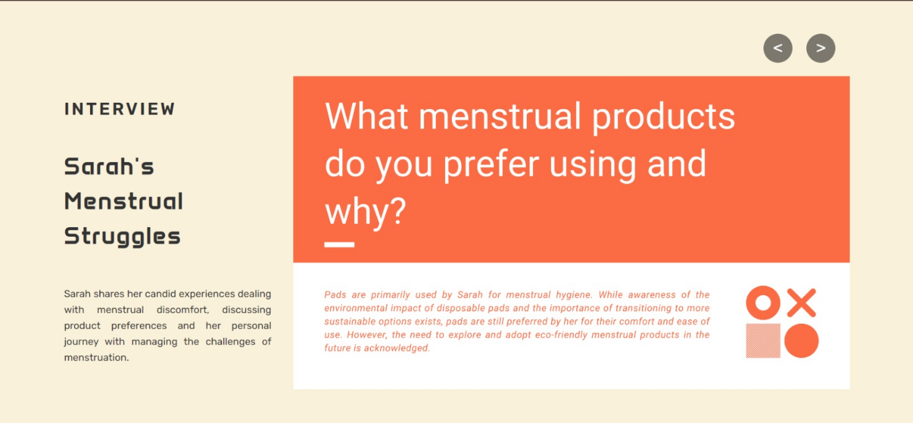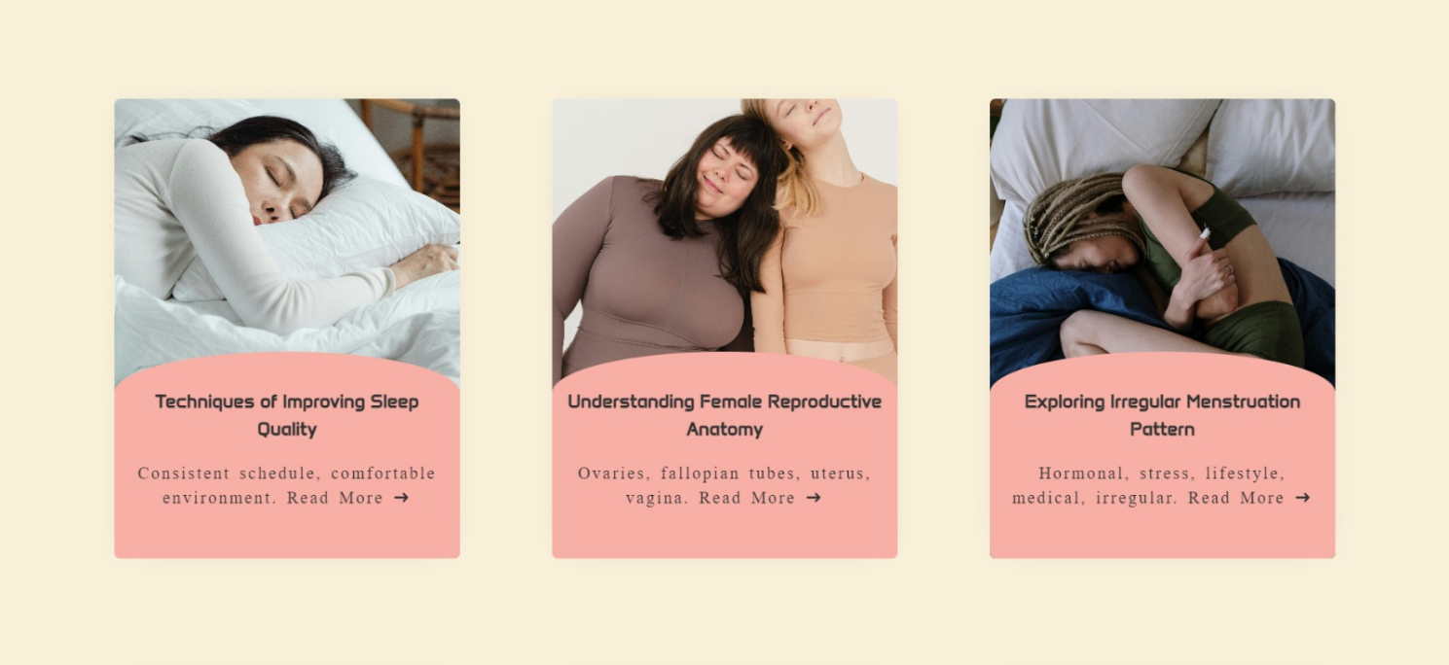

24

**6.2 Nova Wellness - Community**

**A Digital Haven for Women's Health and Well-being**

Nova Community stands as a beacon of empowerment and support, envisioned to cater to the holistic health and well-being of women worldwide. This digital sanctuary is meticulously designed to offer a safe and inclusive space where women can seek solace, access valuable information, and forge meaningful connections with like-minded individuals.

At its core, Nova Community is more than just a sub-website; it's a vibrant ecosystem cultivated by a shared commitment to women's health. Within its virtual walls, women from diverse backgrounds converge to engage in open dialogue, share personal experiences, and foster a sense of camaraderie that transcends geographical boundaries.

**Empowerment Through Knowledge:**

Nova Community is dedicated to empowering women through the exchange of knowledge and experiences. Rather than solely relying on curated articles, the platform fosters an environment where users can actively engage with each other through posts, comments, and shared stories.

**A Supportive Network:**

Beyond its role as an educational resource, Nova Community serves as a nurturing space where women can find support and encouragement in their health journeys. Through interactive features such as comments,and posts, users have the opportunity to engage with a supportive community of peers, offering words of wisdom, empathy, and solidarity. Whether seeking advice on a specific health concern or simply seeking a listening ear, Nova Community fosters an environment of mutual support and understanding.

**Building Connections:**

Central to the ethos of Nova Community is the belief in the transformative power of connection. Through personalized profiles and interactive engagement features, users have the opportunity to build meaningful connections with others who share similar interests and experiences. By linking their professional networks through platforms like LinkedIn and Twitter, users can seamlessly integrate their personal and professional lives, fostering connections that extend beyond the digital realm.

25

**Access to Diverse Perspectives:**

Through the diverse range of posts shared on Nova Community, users gain access to a wealth of perspectives and opinions on various health topics. This exposure to diverse viewpoints enriches their understanding of different health issues and empowers them to make informed decisions about their own well-being.

**Community Support and Validation:**

When users engage with posts by commenting, liking, or sharing, they not only contribute to the conversation but also provide support and validation to others within the community. This sense of solidarity and encouragement reinforces the notion that women are not alone in their health journeys, fostering a supportive and inclusive atmosphere.

**Enriching Understanding:**

Exposure to diverse perspectives enriches users' understanding of health issues by presenting them with alternative viewpoints and experiences. By engaging with posts from individuals with different backgrounds, beliefs, and cultural contexts, users are encouraged to question assumptions, challenge stereotypes, and broaden their horizons. This process of exploration and discovery fosters a more nuanced and empathetic understanding of health topics, empowering users to make informed decisions about their own well-being.

**Fostering Inclusivity and Understanding:**

Ultimately, Nova Community fosters an environment of inclusivity and understanding, where every voice is valued and respected. By embracing diversity and celebrating the richness of human experiences, the platform cultivates a sense of solidarity and unity among its users. Through open dialogue and mutual respect, Nova Community creates a space where individuals can come together to learn, grow, and support each other in their health journeys.

Nova Community serves as a platform for dialogue, discovery, and empowerment, where users can explore diverse perspectives, expand their understanding, and find strength in community solidarity.

**User Authentication and Profile Creation on Nova Community**

1. **Welcome to Nova Community:**

26

Upon entering the Nova Community section, users are greeted with a heartfelt message: *"Welcome to Nova Community - Where Women Empower Women!"* This introduction sets the tone for the supportive and inclusive atmosphere that defines Nova Community.

**2. Sharing Your Story Through Imagery:**

Beyond basic information, Nova Community recognizes the power of visuals in storytelling. Users are encouraged to upload a profile picture, adding a personal touch to their profiles and fostering recognition and connection among community members.

* Visual Representation: A profile picture is more than just an image—it's a reflection of identity and a means of expression. By sharing a photo, users invite others to engage with their stories, experiences, and perspectives on women's health and well-being.

**3. Secure Access and Seamless Experience:**

Nova Community prioritizes user security and convenience. Once users submit their information, the system securely stores their data, ensuring privacy and protection. Subsequent login attempts are made effortless, as users can securely access their profiles with just their email and password.

* Trust and Integrity: The authentication process employed by Nova Community upholds the security and trust of its users. By requiring email and password authentication, the platform ensures the integrity of user accounts and maintains a safe environment for meaningful interactions.

**4. Navigating a User-Centric Interface:**

Nova Community is designed with the user experience in mind. The signup and login interface features intuitive navigation, clear instructions, and visually engaging elements, guiding users through the registration process seamlessly.

* User-Friendly Design: From signup to login, Nova Community prioritizes simplicity and accessibility. The interface is designed to empower users, enabling them to join the community effortlessly and embark on a journey of empowerment and support.

1. **Joining a Community of Empowerment:**

27

By creating their profiles, users become integral members of a vibrant and empowering community dedicated to women's health and well-being. Nova Community fosters connection, support, and collaboration among its members, empowering women to share their stories, seek advice, and champion each other's journeys.

* Strength in Unity: Nova Community embodies the collective strength and resilience of women worldwide. Through shared experiences and mutual support, users find solace, inspiration, and empowerment within the community, forging meaningful connections that transcend geographical boundaries.

In essence, the profile creation process on Nova Community is not just about entering data—it's about empowering women to express their identity, connect with others, and embark on a journey of empowerment and support within a welcoming digital community. Let's dive deeper into the Nova Community interface and its functionalities, providing a comprehensive understanding of its role in empowering women's well-being:

**Unveiling the Nova Community: *Nurturing Women's Well-being Through Digital Connection***

**1. User Profiles:**

Nova Community welcomes users with a vibrant mosaic of user profiles, each representing a unique individual within the community. These profiles are rich with details that foster connection and understanding:

Name, Picture, Location, and Occupation: Users personalize their profiles with essential information, creating a sense of identity and belonging within the community.

Connectivity Options: The platform encourages networking and relationship-building by providing options for users to connect with others through friend requests, facilitating the formation of supportive relationships and alliances.

1. **Posting and Interaction:**

28

Nova Community empowers users to express themselves authentically and engage in meaningful dialogue through various forms of media and communication. Here's a closer look at its interactive features:

Diverse Post Formats: Users can share their stories, insights, and experiences through text, images, videos, attachments, or audio recordings. This versatility accommodates different communication styles and encourages creative expression.

Engagement Opportunities: The platform fosters a culture of interaction and support by allowing users to react to posts with likes and comments. These interactive features facilitate connection and validation, fostering a sense of community and belonging among users.

**3. Advertisements:**

In addition to user-generated content, Nova Community may feature advertisements that align with its mission of promoting women's health and well-being. These advertisements serve as:

Educational Tools: Ads from reputable sources like @periodsandchocolates may promote women's health awareness campaigns, encouraging users to seek support and information through other channels such as Instagram. These ads contribute to the community's collective mission of empowerment and education.

**4. Community Purpose:**

Nova Community serves as a digital sanctuary where women can come together to share, support, and empower one another in their health journeys. Here's how it fulfills its core purpose:

Open Dialogue: Users can openly discuss their health concerns, challenges, and triumphs, creating a space for transparency, empathy, and understanding.

Storytelling and Connection: By sharing their stories and listening to others', users forge meaningful connections and find solace in knowing that they are not alone in their experiences.

Support Networks: The platform facilitates the formation of friendships and support networks, empowering users to provide guidance, encouragement, and solidarity to one another.

29

Empowerment Through Community: Through shared experiences and mutual support, Nova Community empowers women to navigate their health challenges with resilience, confidence, and compassion, fostering a culture of empowerment and self-advocacy.

In essence, Nova Community is not just a platform—it's a movement. It's a digital space where women come together to share, learn, and uplift one another, forging connections, finding support, and championing each other's health and well-being with unwavering solidarity and compassion.

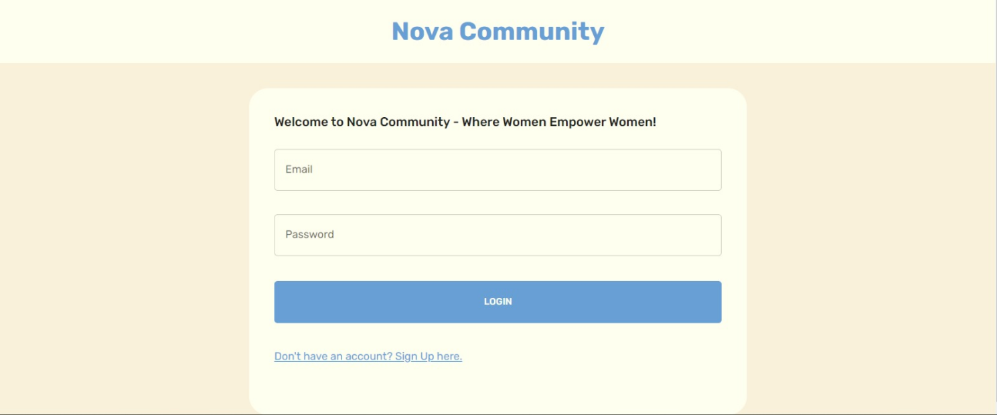

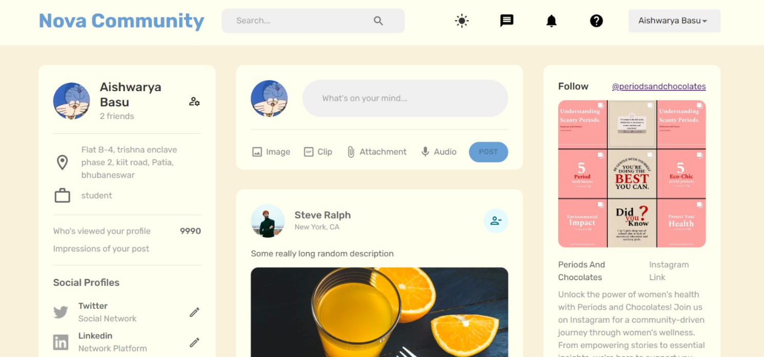

30

**6.3 Nova Wellness - About Us Page**

**Introduction:**

The About Us page serves as an introduction to the passionate individuals driving the Nova Wellness project forward. It provides visitors with insights into the backgrounds, expertise, and motivations of each team member, highlighting their commitment to advancing women's health and well-being.

**Team Members:**

Each team member is presented with a brief description of their role and contribution to Nova Wellness. This includes their unique perspectives, skills, and areas of interest within the project. Visitors can learn about the diverse talents and experiences that collectively drive the mission of empowering women's health.

Ritisha Nanda:

Ritisha is deeply committed to advancing women's health and well-being. As a visionary behind Nova Wellness for Women, she cultivates holistic solutions that empower and uplift. Ritisha strives to redefine the standards of women's healthcare, ensuring every woman thrives in body, mind, and spirit.

Aishwarya Basu:

Aishwarya is a results-driven individual passionate about optimizing algorithms and developing intuitive web applications. With Nova Wellness, she contributes to empowering women through medically verified content and interactive mental health quizzes. Together, they create a space where women prioritize their health and well-being.

Harshita Singh:

As a student in computer science and engineering, Harshita finds immense significance in Nova Wellness. She combines her love for software development with a dedication to promoting women's health. Nova Wellness provides a platform for women to connect, share, and empower each other on their health journeys.

Indrani Sarkar:

31

Indrani, a rookie with a passion for data analytics and data science, is excited to embark on this technical journey. She celebrates the power women hold and believes that learning about her body is the best way to invest in her capital. Indrani sees Nova Health as a platform educating and empowering women about their bodies and overall well-being.

Suprava Samal:

With expertise in both frontend and backend technologies, Suprava creates dynamic and engaging web applications for Nova Wellness. Proficient in HTML, CSS, JavaScript, Node.js, and PHP, she enjoys solving complex problems and implementing innovative solutions to enhance user experiences.

Reetika Samantra:

As a recent graduate eager to launch her career in software development, Reetika brings a wealth of technical skills to Nova Wellness. Her expertise in multiple programming languages, software design patterns, and problem-solving abilities enables her to develop creative solutions that improve patient outcomes and care through technology.

**Mentor:**

Prof. Ajit Kumar Pasayat, the mentor guiding the Nova Wellness project, is featured prominently on the About Us page. Visitors can discover Prof. Pasayat's expertise in women's health advocacy and his role in inspiring and supporting the team throughout the project's development. Prof. Ajit Kumar Pasayat, an Assistant Professor at Kalinga Institute of Industrial Technology (KIIT), DU, India. Prof. Pasayat is not just an educator but an advocate for women's health and empowerment. His belief in the importance of understanding menstruation for all genders has inspired and guided the creation of Nova Wellness. With his guidance, we aim to redefine the narrative surrounding women's health and foster a vibrant, inclusive, and supportive community where every woman feels valued, heard, and empowered.

**Purpose:**

The About Us page also communicates the mission and vision of Nova Wellness, emphasizing the project's goal of redefining the narrative surrounding women's health. It articulates the team's dedication to fostering a supportive and inclusive community where women feel valued, heard, and empowered to prioritize their health and well-being.

32

**Testimonials or Quotes:**

To add a personal touch, the page may include testimonials or quotes from team members, expressing their passion for the project and their commitment to its goals. These testimonials provide visitors with a glimpse into the team's collective enthusiasm and dedication.

**Call to Action:**

Finally, the About Us page concludes with a call to action, inviting visitors to join the Nova Wellness movement. Whether it's through participation, support, or advocacy, visitors are encouraged to become active contributors to the project's mission of empowering women's health and well-being.

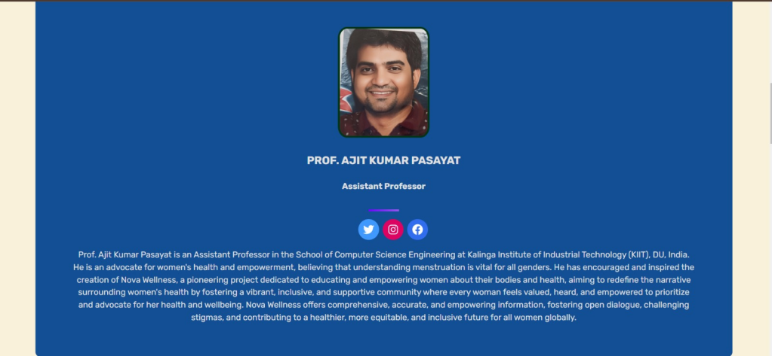

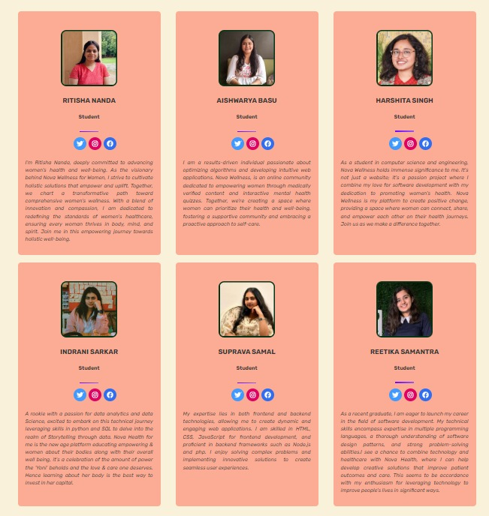

33

**6.4 Nova Wellness - Learn Center**

The Learn section of Nova Wellness offers a comprehensive range of articles covering various aspects of women's health and wellness. Through this report, we aim to shed light on the structure, content, and significance of the Learn section.

II. Overview

The Learn section of Nova Wellness offers over 60 articles covering a wide array of domains, providing valuable insights and information to women seeking to enhance their health and well-being. The articles are organized under the following categories:

III. Detailed Analysis of the Categories

1. Mental Health

Mental Health is a crucial aspect of overall well-being, encompassing emotional, psychological, and social well-being.

The Mental Health section delves into various topics aimed at fostering emotional well-being. Articles addressing stress management, anxiety, depression, and overall mental well-being.

Featured Article: Stress Management Techniques Every Woman Should Know."

2. Sexual Health

Sexual Health is integral to overall health and involves a positive approach to sexuality and sexual relationships.

The Sexual Health section focuses on providing women with the knowledge and resources to make informed decisions about their sexual health. Articles, covers topics such as contraception, sexual education, and reproductive health.

Featured Article: "The Importance of Regular STI Screenings for Women."

3. Women-related Cancers

Women-related Cancers are cancers that specifically affect women, such as cervical cancer, highlighting the importance of regular screenings and awareness.This section emphasizes the importance of awareness, early detection, and prevention of women-related cancers. Articles cover breast cancer, cervical cancer, ovarian cancer, and more.

34

Featured Article: "The Role of Early Detection in Women-related Cancers."

4. Women's Menstrual Health

Women's Menstrual Health is an essential aspect of women's health, involving the menstrual cycle and related issues like period pain, irregularities, and menopause.

The Women's Menstrual Health section provides insights and advice on managing menstrual health. Covers topics such as menstrual cycle irregularities, menopause, and period pain management.

Featured Article: "Understanding Your Menstrual Cycle: A Comprehensive Guide."

5. Emotional Intelligence and Resilience

Emotional Intelligence is key skills for navigating life's challenges, fostering self-awareness, empathy, and the ability to bounce back from adversity.

The Emotional Intelligence and Resilience section focuses on building emotional strength and resilience. Covers topics such as self-awareness, empathy, and coping mechanisms.

Featured Article: "Building Emotional Resilience: How to Bounce Back from Life's Challenges."

6. Wellness & Optimal Living

Wellness & Optimal Living focuses on staying healthy and well, bridging the gap between self-awareness and knowledge of women.

This section offers holistic insights into maintaining overall well-being. Covers topics such as nutrition, fitness, and holistic well-being.

Featured Article: "The Connection Between Nutrition and Mental Health."

IV. Frequently Asked Questions (FAQ)

The FAQ section is a valuable resource providing answers to common questions, such as:

1. How will I feel when I have my period?

2. Can I get pregnant while on my period?

3. Is my vaginal discharge normal?

4. Are there specific nutritional needs that women should focus on?

5. What are the signs of a urinary tract infection (UTI)?**

35

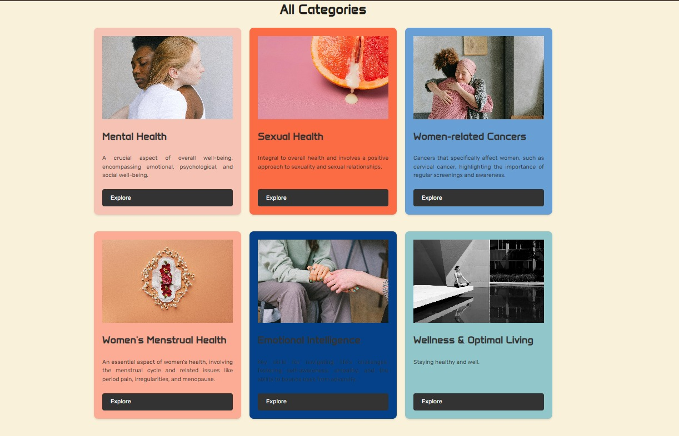

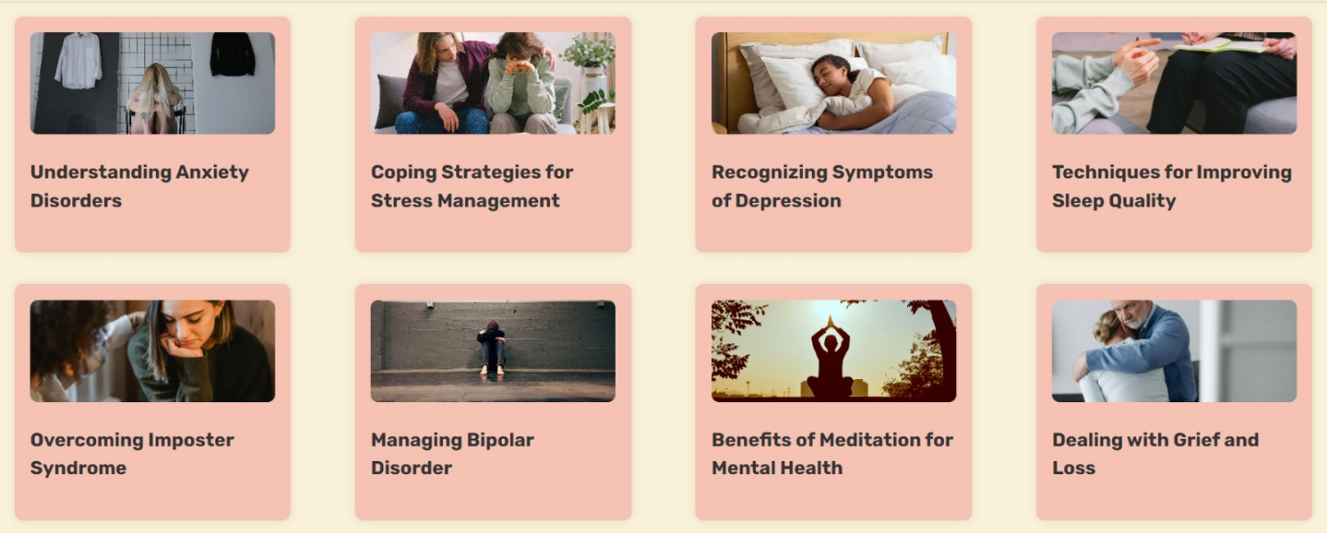

36

**6.4.1 Nova Wellness - Blogging**

Sub Website for articles

Nova Wellness - Blogging serves as an extension of the Learn Center, offering a dedicated space for in-depth articles on various women's health and wellness topics. This sub-website is designed to complement the Learn Center by providing a platform where users can delve deeper into specific subjects, gain valuable insights, and broaden their understanding of women's health issues.

Within the Nova Wellness - Blogging platform, articles are categorized according to the six key areas covered in the Learn Center: Mental Health, Sexual Health, Women's Menstrual Health, Women-related Cancers, Emotional Intelligence, and Wellness and Optimal Living. Each category features a curated collection of articles written by experts in the field, healthcare professionals, and community members who have personal experiences and insights to share.

One of the unique features of Nova Wellness - Blogging is the opportunity for users to contribute their own articles. This user-generated content enriches the platform by providing diverse perspectives, personal stories, and practical advice that resonate with a wider audience by posting articles. Whether it's sharing personal experiences, discussing new research findings, or offering tips on self-care and wellness, users have the freedom to express themselves and contribute to the collective knowledge base.

The Nova Wellness - Blogging platform is more than just a repository of articles; it's a dynamic community where knowledge is shared, experiences are exchanged, and connections are made. By empowering users to create and share content, we foster a collaborative and supportive environment that encourages learning, exploration, and self-discovery. Through this extension of the Learn Center, Nova Wellness - Blogging aims to inspire and educate women, helping them make informed decisions about their health and well-being while fostering a sense of community and belonging

37

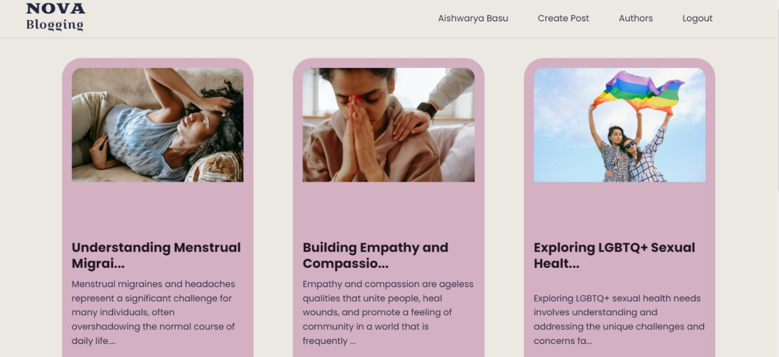

**Community vs Blogging Functionalities:**

Optimizing Website Experience for Enhanced Engagement

Ensuring a seamless and engaging user experience is paramount in website development. By strategically organizing and separating the functionalities of a website, we can cater to specific user needs and preferences, maximizing engagement and satisfaction.

Distinct User Experience:

By separating the community and blogging functionalities, you can create distinct user experiences tailored to each purpose. The community section can focus on user interactions, discussions, and social engagement, while the blogging section can prioritize long-form content creation, storytelling, and article-style posts.

Specialized Features:

Keeping the blogging functionality separate allows you to implement specialized features specifically designed for bloggers. This might include features such as customizable layouts, SEO optimization tools, analytics for tracking post performance, and integration with external platforms like Medium or WordPress.

38

Scalability and Maintainability:

Separating the blogging functionality into its own module can make your codebase more modular and easier to maintain. It allows you to scale each component independently, adding new features or making changes without affecting the other part of the website.

Targeted Audience:

Some users might be primarily interested in engaging with the community aspect of your website, while others might be more interested in creating and consuming blog content. By offering both functionalities separately, you cater to different user preferences and interests, potentially attracting a broader audience.

Brand Identity:

Having distinct sections for community and blogging can help to establish a clear brand identity for your website. Users will know what to expect when they visit each section, and you can tailor your branding, messaging, and design elements accordingly.

**6.5 Nova Wellness - Mental Health Check**

The Mental Health Check section of Nova Wellness' website is a dedicated space for nurturing mental well-being through interactive quizzes. Recognizing that mental health is just as important as physical health, Nova Wellness is committed to providing accessible resources to support individuals on their journey towards greater well-being. The section covers various mental health conditions and offers personalized insights to empower mental wellness. The following report details the purpose and content of the Mental Health Check section and provides an overview of the PHQ-9, GAD-7, ISI, and MDQ quizzes featured on the website.

1. Patient Health Questionnaire (PHQ-9)

Purpose:

The PHQ-9 quiz is a widely used tool in healthcare designed to screen for symptoms of depression and assess their severity through nine questions.

Format:

39

The PHQ-9 quiz consists of nine questions, each targeting different symptoms of depression, including mood, sleep, appetite, and energy levels.

Scoring:

The quiz provides a score that indicates the severity of depression symptoms, ranging from minimal to severe. The scoring system helps individuals understand the level of attention they might need.

Interpretation:

The interpretation of the PHQ-9 quiz score can guide individuals in determining whether they should seek further evaluation and support from a healthcare professional.

Objective:

The PHQ-9 quiz aims to help users identify potential depression symptoms and the severity of these symptoms, facilitating early intervention and appropriate treatment.

2. Generalized Anxiety Disorder (GAD-7)

Purpose:

The GAD-7 quiz is a brief self-assessment tool designed to measure the severity of generalized anxiety disorder symptoms.

Format:

The GAD-7 quiz consists of seven questions, each targeting different symptoms of generalized anxiety disorder, including nervousness, worry, and restlessness.

Scoring:

Similar to the PHQ-9, the GAD-7 quiz provides a score indicating the severity of anxiety symptoms, ranging from minimal to severe.

Interpretation:

The interpretation of the GAD-7 score helps individuals determine the severity of their anxiety symptoms and whether they should consider seeking professional support.

Objective:

The GAD-7 quiz aims to assist users in recognizing symptoms of generalized anxiety disorder, facilitating early intervention and appropriate treatment.

3. Insomnia Severity Index Questionnaire (ISI)

Purpose:

40

The ISI quiz evaluates sleep difficulties based on seven questions, offering guidelines for scoring and interpretation.

Format:

The ISI quiz comprises seven questions that evaluate the severity of insomnia symptoms, including difficulty falling asleep, staying asleep, and satisfaction with sleep.

Scoring:

The ISI quiz provides a score indicating the severity of insomnia symptoms, ranging from no clinically significant insomnia to severe clinical insomnia.

Interpretation:

Users can interpret their ISI score to understand the severity of their insomnia symptoms and determine whether they should seek professional assistance.

Objective:

The ISI quiz aims to help users identify and understand their insomnia symptoms, guiding them towards appropriate intervention and treatment.

4. Mood Disorder Questionnaire (MDQ)

Purpose:

The MDQ quiz assesses potential symptoms of manic-depressive illness, aiding in determining the need for further medical evaluation.

Format:

The MDQ quiz consists of a series of questions designed to screen for symptoms of bipolar disorder, including periods of elevated mood, irritability, and increased energy levels.

Scoring:

The MDQ quiz provides a score indicating the likelihood of bipolar disorder, helping individuals understand whether further evaluation is necessary.

Interpretation:

Individuals can interpret their MDQ score to determine whether they should seek further medical evaluation for bipolar disorder.

Objective:

The MDQ quiz aims to help users identify potential symptoms of bipolar disorder, facilitating early intervention and appropriate treatment.

41

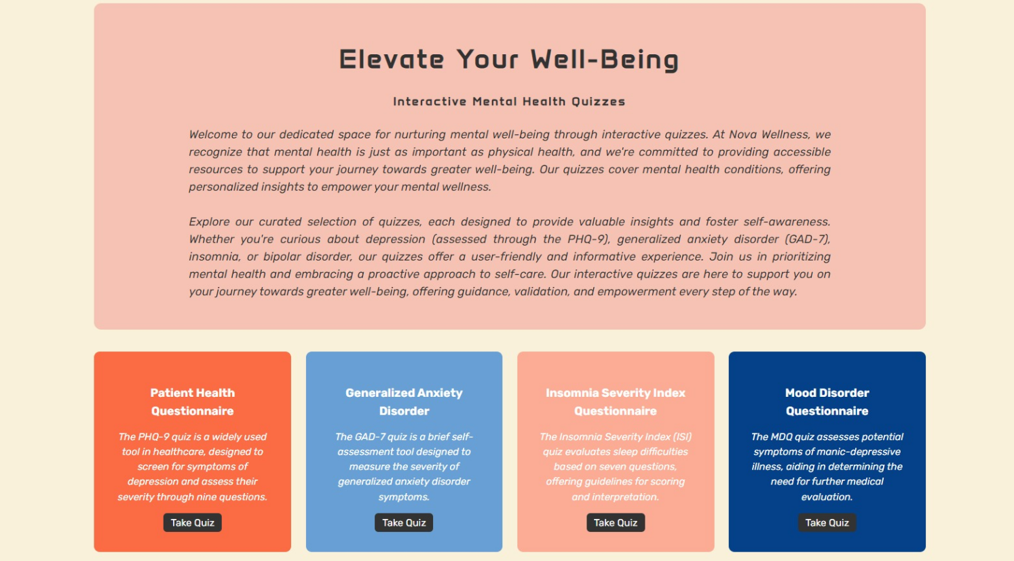

42

**6.5 Nova Wellness - Social Media Engagement: 'Periods and Chocolates'**

Nova Wellness Instagram Page: @periodsandchocolates

**@periodsandchocolates** is Nova Wellness' Instagram page where we conduct engaging Q&A sessions, share interactive posts, and reveal new features. This platform serves as a vital hub for our community, facilitating connections with healthcare professionals such as doctors and nutritionists. Through this interactive space, we aim to nurture mental well-being, providing a supportive environment for individuals to explore and prioritize their mental health journey.

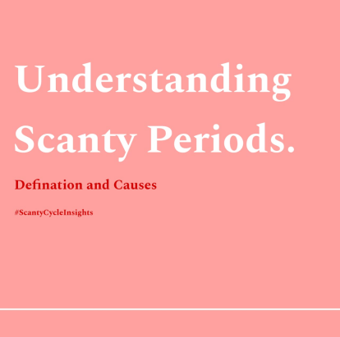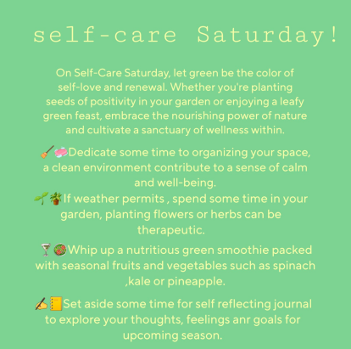

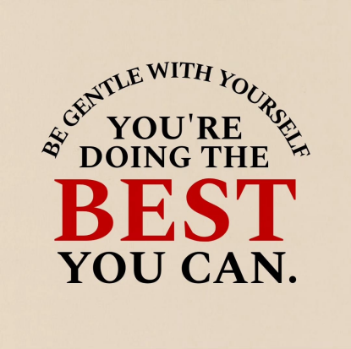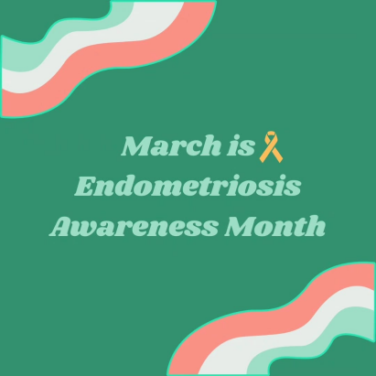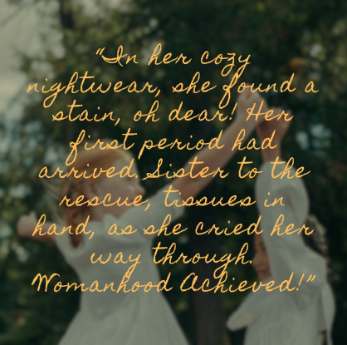

'Periods and Chocolates' on Instagram is more than just a social media page; it's a vibrant community dedicated to empowering women, promoting mental well-being, and fostering connections. By leveraging the power of social media, we strive to reach a wider audience, raise awareness about women's health issues, and inspire positive change. Through interactive content, expert insights, and genuine engagement, we aim to make a meaningful impact on the lives of women everywhere, encouraging them to prioritize their health, embrace self-care, and celebrate their unique journeys.

43

Nova Wellness is more than just a platform; it's a movement towards reshaping the landscape of women's health and well-being. With a strong emphasis on user engagement and empowerment, we've meticulously designed an intuitive and user-friendly interface that serves as a gateway to a wealth of resources and support mechanisms. The Nova Community community fosters a space where women can connect, share experiences, and engage in meaningful discussions about their health concerns, creating a supportive and nurturing environment.

The Learn Center and Nova Blogging sections are curated to provide women with comprehensive and up-to-date information on a myriad of health topics, ranging from mental and sexual health to women-related cancers and menstrual health. These educational resources are not only informative but also tailored to resonate with the diverse needs and experiences of women globally. Additionally, the Women Health Check feature offers personalized health assessments, allowing users to gain insights into their health status and seek appropriate medical guidance when needed.

In essence, Nova Wellness aspires to be more than just a website; it aims to be a trusted companion on every woman's health journey, providing the tools, resources, and support needed to make informed decisions and take proactive steps towards achieving optimal health and well-being. Our mission is to empower women to prioritize their health, advocate for their well-being, and lead fulfilling lives, thereby contributing to a healthier, more equitable, and inclusive future for all women globally.

44

CHAPTER 7

TECHNOLOGIES USED

**________________________________________________**

**Website Development for Nova Wellness**

The creation of the Nova Wellness website stems from our commitment to providing a comprehensive and empowering platform dedicated to women's health and wellness. Designed with a user-centric approach, the website aims to offer an intuitive and engaging experience, facilitating easy navigation and access to valuable resources and information tailored to meet the diverse needs of women worldwide.

**7.1 Front-end Technologies**

React.js: React.js serves as the backbone of our front-end development, allowing us to build reusable and interactive user interface components. Its component-based architecture facilitates the creation of dynamic and responsive web pages, enhancing the overall user experience and engagement on the Nova Wellness platform.

HTML5 & CSS3: HTML5 and CSS3 are utilized for structuring and styling the website, ensuring semantic markup, compatibility, and responsiveness across various devices and browsers. They play a crucial role in creating a visually appealing and user-friendly interface, reflecting the brand identity and enhancing the aesthetic appeal of the Nova Wellness platform.

JavaScript (ES6+): JavaScript (ES6+) is employed for adding interactivity, animations, and dynamic features to the website. Its versatility and robustness enable the implementation of complex functionalities and user interactions, enriching the user experience and enhancing the overall interactivity and engagement on the Nova Wellness platform.

Bootstrap: Bootstrap, a leading front-end framework, is leveraged for developing responsive and mobile-first designs. Its grid system, components, and utilities enable us to create consistent and

45

adaptive layouts, ensuring optimal viewing and interaction experience across different devices, screen sizes, and orientations.

**7.2 Back-end Technologies**

Node.js: Node.js serves as the core backend technology, enabling server-side scripting and facilitating the development of scalable and efficient back-end services. Its non-blocking, event-driven architecture allows for rapid development and deployment of server-side applications, supporting seamless integration with front-end technologies and ensuring smooth and consistent performance on the Nova Wellness platform.

Express.js: Express.js, a minimalist web application framework for Node.js, is utilized for building robust, secure, and scalable web applications and APIs. Its simplicity, flexibility, and extensibility streamline the development process, enabling us to create efficient and maintainable backend services to support the diverse functionalities and features of the Nova Wellness platform.

**ServerRoutes**  
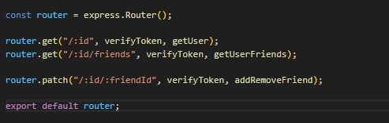

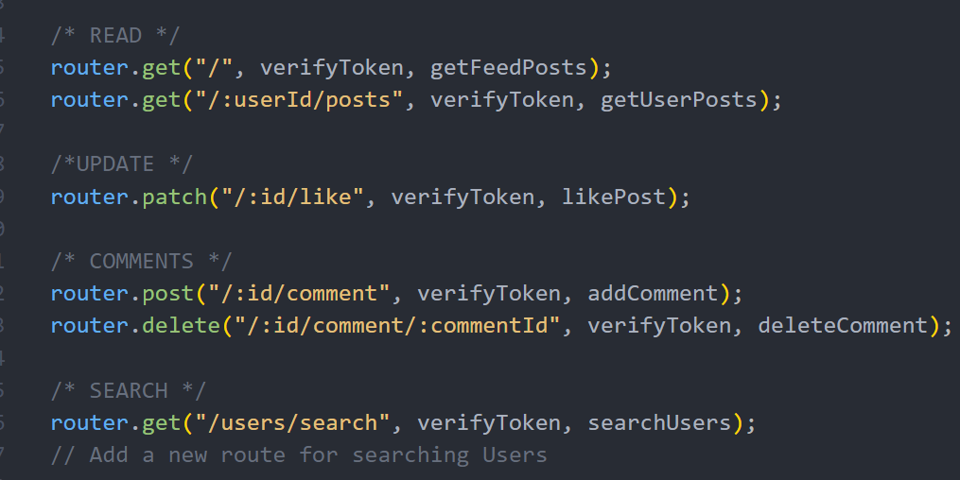

46

**Server Controllers**

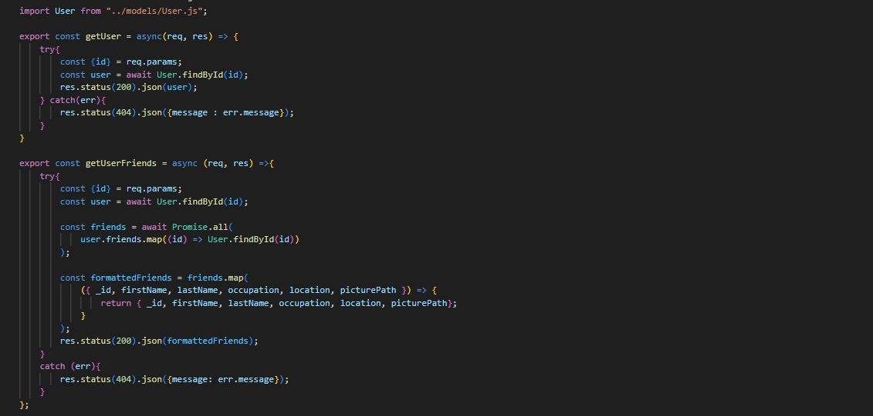

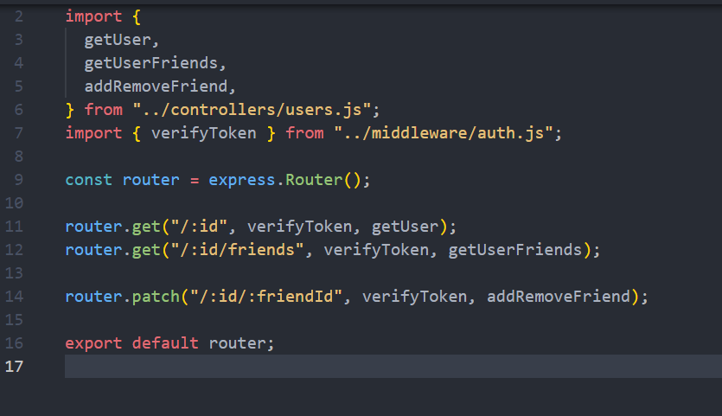

**7.3 Database Management System**

MongoDB: MongoDB, a NoSQL database system, is employed for storing, retrieving, and managing structured and unstructured data related to users, content, and interactions on the Nova Wellness platform. Its flexible schema, scalability, and performance optimization capabilities provide a robust and efficient solution for handling diverse data types and supporting dynamic content management and personalization features.

47

**Mongodb layout**

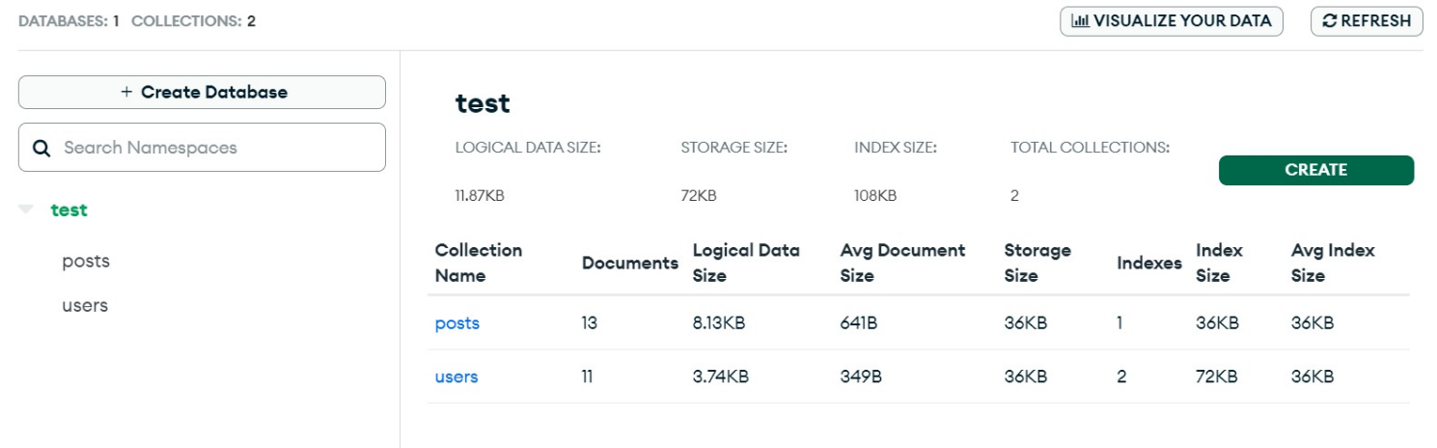

**Schema of the database**



**Format of Post storage in the database**

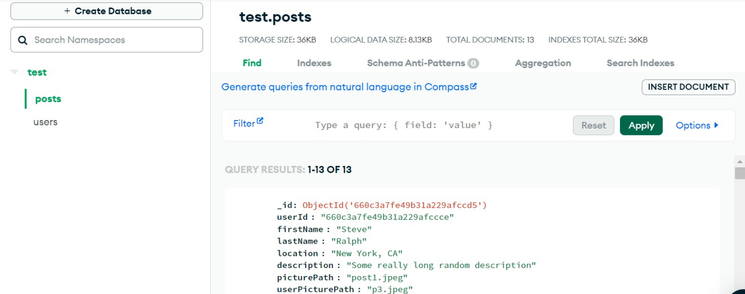

48

**7.4 Security Measures**

HTTPS: HTTPS, implemented using SSL/TLS certificates, encrypts and secures data transmission between the web server and user's browser on the Nova Wellness platform. It ensures data integrity, confidentiality, and protection against potential security threats and vulnerabilities, enhancing trust, and confidence among users and safeguarding sensitive information and interactions.

JWT (JSON Web Tokens): JWT (JSON Web Tokens) is used for implementing secure authentication and authorization mechanisms on the Nova Wellness platform. It provides a compact, URL-safe means of representing claims to be transferred between two parties, facilitating seamless and secure access control, user authentication, and personalized user experiences based on roles, permissions, and preferences.

Multer: Multer is integrated into the backend to handle file uploads, enabling users to upload images and multimedia content seamlessly. It provides a middleware for Express.js to handle multipart/form-data, facilitating efficient file storage, validation, and retrieval, supporting diverse content types and enhancing user engagement and interactivity on the Nova Wellness platform.

**Nova Blogging Development**

Nova Blogging serves as a vital component of the Nova Wellness platform, offering a rich repository of informative and empowering articles, resources, and insights tailored to meet the diverse needs of women seeking valuable information and guidance on various women's health and wellness topics.

Developed with the same robust tech stack as Nova Wellness, including React.js for dynamic user interfaces, Node.js and Express.js for scalable backend services, and MongoDB for flexible data management, Nova Blogging ensures an intuitive, engaging, and secure user experience. Leveraging these cutting-edge technologies, Nova Blogging delivers high-quality content with optimal performance, accessibility, and user engagement, reinforcing Nova Wellness's commitment to empowering women through comprehensive and reliable information.

49

The development of Nova Wellness and its core component, Nova Blogging, epitomizes our commitment to revolutionizing women's health and wellness. Leveraging the power of the MERN stack—MongoDB, Express.js, React.js, and Node.js—we've crafted a comprehensive platform that seamlessly integrates valuable information, dynamic engagement, and personalized empowerment.

This unified approach underscores our dedication to delivering a unified, intuitive, and empowering experience across Nova Wellness, ensuring that every interaction reflects our commitment to revolutionizing women's health globally.

50

CHAPTER 8

CONTENT STRATEGY

**________________________________________________**

At Nova Wellness, our commitment lies in fostering holistic well-being for women worldwide by delivering insightful and empowering content. With a focus on addressing the multifaceted health and wellness requirements of women, we delve into a diverse range of topics through our Nova Blog. From nutrition and fitness to mental health and self-care, our content is meticulously curated to resonate with our audience's unique needs. Upholding the highest standards of accuracy and reliability, we prioritize evidence-based information sourced not only from research papers but also from trusted medical platforms like Practo. Our content creation process involves collaboration with experienced nutritionists, who provide expert opinions and guidance, ensuring that every piece we publish is both trustworthy and beneficial. With Nova Wellness, women can confidently navigate their health journey armed with knowledge and support.

**8.1 Overview of the Content for Nova Wellness**

Nova Wellness is dedicated to offering a comprehensive range of content designed to educate, inspire, and empower women across the globe on various facets of their health and well-being. Our content is thoughtfully categorized into specialized areas to cater to the diverse needs of our audience, encompassing:

Women's Menstrual Health: Our articles delve into menstrual well-being, menstrual disorders, menstrual hygiene, and menstrual cycle management. We provide valuable information, advice, and support to help women understand and effectively manage their menstrual health and well-being. Additionally, we cover topics such as natural remedies for menstrual cramps, the benefits of menstrual tracking, and the impact of hormonal changes throughout the menstrual cycle.

Sexual Health: We offer comprehensive coverage of sexual health topics, including sexual wellness, reproductive health, contraception, sexually transmitted infections (STIs), and sexual and intimate relationships. Our content provides insights, guidance, and resources to promote

51

sexual health, safety, and satisfaction among women. We also address issues related to sexual dysfunction, sexual consent, and sexual pleasure, offering inclusive and non-judgmental information to help women make informed choices about their sexual health and relationships.

Women-related Cancers: Our in-depth articles focus on women-related cancers such as breast cancer, cervical cancer, ovarian cancer, uterine cancer, and other gynecological cancers. We cover risk factors, prevention, screening, diagnosis, treatment, and survivorship to raise awareness, provide support, and encourage early detection and intervention. Additionally, we discuss the role of genetics, lifestyle factors, and environmental exposures in cancer development, as well as the importance of regular screenings and preventive measures.

Women Wellness: Adopting a holistic approach to women's wellness, we concentrate on physical health, mental health, emotional well-being, nutrition, fitness, self-care, stress management, and healthy lifestyle choices. We offer practical advice, tips, strategies, and resources to support women in maintaining and enhancing their overall health and wellness. Our content includes topics such as mindfulness and meditation, the benefits of a balanced diet, effective workout routines, and strategies for managing stress and improving sleep quality.

Emotional Intelligence and Resilience: Our articles explore the concepts of emotional intelligence, resilience, self-awareness, self-management, social awareness, relationship management, and emotional well-being. We provide insights, tools, and techniques to help women develop and strengthen their emotional intelligence and resilience to navigate life's challenges effectively. Additionally, we offer guidance on building healthy relationships, setting boundaries, and enhancing communication skills to foster emotional well-being and personal growth.

Healthy Aging: We focus on the importance of maintaining health and well-being as women age, covering topics such as menopause, bone health, cardiovascular health, cognitive function, and preventive care. Our content offers guidance, tips, and resources to help women embrace aging gracefully and maintain a high quality of life. We also address the unique health concerns and challenges faced by older women, providing practical advice and support to help them lead fulfilling and active lives.

52

Nutrition and Diet: We offer evidence-based information on nutrition, diet, healthy eating habits, and weight management. Collaborating with registered dietitians and nutrition experts, we provide practical tips, meal plans, recipes, and dietary guidelines to help women make informed food choices and maintain a balanced diet. Our content covers a wide range of topics, including the benefits of whole foods, the importance of hydration, mindful eating practices, and strategies for managing food allergies and intolerances.

**8.2 Importance of Evidence-based Information**

At Nova Wellness, we prioritize the importance of evidence-based information, ensuring that our content is credible, reliable, and based on current scientific research, medical guidelines, and expert opinions. We collaborate with healthcare professionals, experts, researchers, and organizations to review, validate, and update our content regularly to ensure accuracy, relevance, and effectiveness in addressing women's health and wellness needs. Our commitment to providing trustworthy and up-to-date information enables women to make informed decisions about their health, empowering them to lead healthier, happier lives.

**8.3 Content Creation and Curation Process**

At Nova Wellness, our content creation and curation process is meticulously structured to uphold quality, consistency, and relevance across all platforms. We begin with collaborative ideation and planning, leveraging research and insights to identify pertinent topics and trends in women's health and wellness. Our dedicated team then develops and produces high-quality, original content, tailored to meet the diverse needs of women seeking comprehensive information on topics such as hormonal regulation in Women’s Menstrual Health, immunological aspects of Sexual Health, genetic and cellular mechanisms underlying Women-related Cancers, nutritional and physiological dimensions of women wellness, and the psychological foundations of Emotional Intelligence and Resilience. Prior to publication, all content undergoes a rigorous review and validation process to ensure accuracy, credibility, and alignment with current medical guidelines, research, and best practices. This systematic approach enables us to deliver engaging and informative content that empowers women to make informed decisions about their health, well-being, and the evolving landscape of wellness.

53

**8.4 Nutritionists' Opinion and Guidance**

As part of our commitment to providing comprehensive and personalized health and wellness information, Nova Wellness collaborates with certified nutritionists and dietitians to offer expert opinions, guidance, and advice on nutrition, diet, and healthy eating for women:

Nutritional Insights and Recommendations: Expert insights, recommendations, and guidelines on balanced nutrition, healthy eating habits, meal planning, dietary supplements, and nutritional considerations specific to women's health, reproductive health, pregnancy, breastfeeding, menopause, and aging, to support women in making informed decisions and adopting healthy eating and lifestyle choices.

Nutrition Tips and Recipes: Practical nutrition tips, delicious and nutritious recipes, meal ideas, and cooking techniques tailored to women's nutritional needs, preferences, and goals, to inspire and empower women to prioritize and maintain their nutritional health and well-being effectively.

The vision for Nova Wellness is to empower women with comprehensive information on diverse topics related to women's health and wellness. Through our content on Women’s Menstrual Health, Sexual Health, Women-related Cancers, women WELLNESS, and Emotional Intelligence and Resilience, we aim to foster open dialogue, challenge stigmas, and build an inclusive and supportive community. By providing valuable insights and evidence-based information, we strive to ensure every woman feels valued, heard, and empowered to prioritize her health and well-being. Whether seeking detailed articles on specific health issues or gaining basic knowledge to enhance overall wellness, we invite women to explore our content and join us in shaping a healthier, more equitable future for all women globally.

54

CHAPTER 9

CHALLENGES

AND SOLUTIONS

**________________________________________________**

Developing and maintaining a comprehensive women's health and wellness platform like Nova Wellness comes with its unique set of challenges. However, with strategic planning, innovative solutions, and continuous collaboration, we have identified and addressed these challenges effectively to ensure the delivery of high-quality, reliable, and user-friendly content and services to our community of women worldwide.

**9.1 Content Creation and Validation**

Challenge: Ensuring the creation of accurate, credible, and evidence-based content that resonates with our target audience while maintaining consistency, quality, and relevance across all platforms and categories.

Solution: Implementing a systematic content creation and curation process involving collaborative brainstorming, research, planning, development, review, validation, and optimization, in collaboration with healthcare professionals, experts, nutritionists, and dietitians, to ensure accuracy, credibility, and alignment with current medical guidelines, research, and best practices in women's health and wellness.

**9.2 User Engagement and Retention**

Challenge: Enhancing user engagement, interaction, and retention to foster a vibrant, inclusive, and supportive community where every woman feels valued, heard, and empowered to advocate for her health and well-being.

Solution: Implementing a multi-faceted user engagement strategy, including interactive content, community platforms, mental health checks, social media engagement, personalized

55

recommendations, user-friendly navigation, responsive design, and collaborative partnerships with healthcare professionals, experts, organizations, and community influencers to encourage active participation, foster connections, build relationships, and promote user loyalty and retention.

**9.3 Technical Challenges and Their Resolutions**

Challenge: Addressing technical challenges, including website performance, speed, accessibility, compatibility and availability, to ensure a seamless and enjoyable user experience across all devices and platforms.

Solution: Leveraging the MERN stack (MongoDB, Express.js, React.js, Node.js) to develop a robust, scalable, and secure technology infrastructure, implementing advanced web development technologies, frameworks, and tools, and following best practices in web design, development, optimization, and maintenance to enhance website performance, speed, accessibility, compatibility, security.. Regular technical audits, updates, and improvements are conducted to ensure a seamless, enjoyable, and accessible user experience for all our users.

**9.4 Feedback and Continuous Improvement**

Challenge: Collecting, analyzing, and integrating user feedback, suggestions, and insights to identify areas for improvement, enhance content quality, relevance, and user experience, and drive continuous innovation and excellence in our content, services, and community engagement initiatives.

Solution: Implementing a comprehensive feedback collection and analysis system, including user surveys, community forums, and social media engagement, to gather valuable user feedback, insights, and suggestions, conducting regular reviews, evaluations, and analyses of user feedback, and leveraging the insights gained to inform and guide continuous improvement, innovation, and enhancement in our content, services, community engagement initiatives, and overall user experience.

56

By addressing these challenges with innovative solutions and strategic approaches, Nova Wellness is committed to delivering a trusted, comprehensive, and user-friendly online platform, fostering a vibrant, inclusive, and supportive community where every woman feels valued, heard, and empowered to prioritize and advocate for her health and well-being, thereby contributing to a healthier, more equitable, and inclusive future for all women globally. Nova Wellness is dedicated to providing a trusted, comprehensive, and user-friendly online platform, fostering a vibrant, inclusive, and supportive community where every woman feels valued, heard, and empowered to advocate for her health and wellbeing.

57

CHAPTER 10

WOMEN’S WELLNESS

AND LIFESTYLE

**________________________________________________**

Women's wellness and lifestyle play a crucial role in promoting overall health, well-being, and quality of life. This section explores various aspects of women's wellness and lifestyle, including nutrition and diet, exercise and fitness regimes tailored for women, mental health and well-being, stress management, relaxation techniques, and hygiene, to empower women to make informed decisions and adopt healthy lifestyle choices.

**10.1 Nutrition and Diet for Women**

Proper nutrition and diet are fundamental to women's health, supporting hormonal balance, reproductive health, immune function, energy levels, and overall well-being.

Balanced Diet: A balanced diet rich in fruits, vegetables, whole grains, lean proteins, and healthy fats is essential for meeting nutritional needs, promoting optimal health, and reducing the risk of chronic diseases and conditions common in women.

Nutritional Needs: Women have unique nutritional needs influenced by various factors, including age, life stage, reproductive health, and physical activity levels, requiring tailored dietary strategies, meal planning, and nutritional guidance to support optimal health and well-being.

Nutritional Supplements: In some cases, nutritional supplements, including vitamins, minerals, and herbal supplements, may be recommended to address specific nutritional deficiencies, support health conditions, or optimize health outcomes.

58

**10.2 Exercise and Fitness Regimes Tailored for Women**

Regular physical activity and exercise are essential for maintaining cardiovascular health, muscle strength, flexibility, bone density, metabolic health, and mental well-being.

Tailored Exercise Programs: Exercise and fitness regimes tailored for women focus on addressing women's unique physiological, biomechanical, and hormonal needs, preferences, and goals, including strength training, cardiovascular exercise, flexibility training, and functional fitness to promote optimal health, fitness, and performance.

Physical Activity Guidelines: Following physical activity guidelines and recommendations, including frequency, intensity, duration, and type of exercise, is essential for optimizing health benefits, reducing the risk of chronic diseases, and promoting healthy aging.

Home Workouts and Online Fitness Programs: Access to home workouts, online fitness programs, virtual fitness classes, and personalized coaching and support can facilitate adherence to regular physical activity and exercise routines, promote accountability, and foster motivation, engagement, and enjoyment.

**10.3 Mental Health and Well-being**

Mental health and well-being are integral components of women's overall health and quality of life, encompassing emotional, psychological, and social aspects of well-being.

Emotional and Psychological Support: Seeking emotional and psychological support, counseling, therapy, and mental health resources can help women navigate life's challenges, transitions, and stressors, manage mental health issues, and promote resilience, coping, and well-being.

Mindfulness and Mind-Body Practices: Incorporating mindfulness, meditation, yoga, tai chi, and other mind-body practices into daily routines can help reduce stress, anxiety, depression, improve mood, enhance self-awareness, focus, and concentration, and promote relaxation, calm, and inner peace.

59

Mental Health Awareness and Advocacy: Raising awareness, challenging stigmas, advocating for mental health, and promoting open dialogue, education, and support around mental health issues, concerns, and needs are essential for fostering a supportive, inclusive, and empowering environment and promoting mental health literacy, acceptance, and understanding.

**10.4 Stress Management and Relaxation Techniques**

Effective stress management and relaxation techniques are essential for promoting resilience, coping, balance, and well-being, reducing the risk of stress-related health issues, and enhancing overall quality of life.

Stress Management Strategies: Adopting stress management strategies, including time management, prioritization, delegation, problem-solving, assertiveness, and communication skills, can help women manage and reduce stress, improve productivity, and foster a sense of control, empowerment, and well-being.

Relaxation Techniques: Practicing relaxation techniques, such as deep breathing, progressive muscle relaxation, guided imagery, aromatherapy, massage, and hydrotherapy, can help promote relaxation, calm, and stress relief, reduce muscle tension, anxiety, and promote restful sleep, and enhance overall well-being and quality of life.

Work-Life Balance: Achieving and maintaining a healthy work-life balance, setting boundaries, practicing self-care, and engaging in enjoyable and fulfilling activities, hobbies, and interests can help prevent burnout, fatigue, and overwhelm, and promote overall well-being, happiness, and life satisfaction.

**10.5 Hygiene and Personal Care**

Personal hygiene and care are essential for maintaining cleanliness, health, and well-being, preventing infections, and promoting confidence, self-esteem, and social interactions.

Personal Hygiene Practices: Adopting good personal hygiene practices, including regular handwashing, dental care, skincare, haircare, nail care, and menstrual hygiene management, can

60

help prevent infections, maintain skin, hair, and oral health, and promote overall cleanliness, freshness, and well-being.

Safe and Healthy Practices: Practicing safe and healthy personal care habits, including proper hygiene, grooming, and skincare routines, using high-quality, hypoallergenic, and non-toxic products and materials, and seeking medical advice and support when necessary, are essential for preventing skin and health issues, allergies, and promoting overall health, safety, and well-being.

Self-Care and Self-Love: Prioritizing self-care, self-love, and self-acceptance, embracing body positivity, and celebrating diversity, individuality, and uniqueness can help women cultivate a positive body image, improve self-esteem, confidence, and well-being, and foster a healthy, respectful, and nurturing relationship with themselves and others.

Women's wellness and lifestyle encompass various aspects, including nutrition and diet, exercise and fitness regimes tailored for women, mental health and well-being, stress management, relaxation techniques, and hygiene and personal care, that play a crucial role in promoting overall health, well-being, and quality of life. Nova Wellness is committed to empowering women with comprehensive, accurate, and empowering information, fostering open dialogue, challenging stigmas, and building a vibrant, inclusive, and supportive community where every woman feels valued, heard, and empowered to prioritize and advocate for her health and wellbeing, thereby contributing to a healthier, more equitable, and inclusive future for all women.

61

CHAPTER 11

CONCLUSION **________________________________________________**

Nova Wellness stands as a revolutionary platform at the forefront of women's health and well-being, poised to transform the way women access and engage with health-related information and resources. With a holistic and user-centric approach, we have meticulously designed a comprehensive ecosystem that integrates cutting-edge technologies, interactive community engagement, and educational content tailored to meet the diverse and evolving needs of women globally.

Our commitment to empowering women is evident across all facets of Nova Wellness. The Learn Center serves as an educational hub, meticulously curated to address key aspects of women's health, from mental and sexual health to menstrual health, women-related cancers, emotional intelligence, and optimal living. Complementing the Learn Center is our Nova Blogging platform, where users can delve deeper into specific health topics, gain valuable insights, and contribute to a collective knowledge base enriched by diverse perspectives, personal stories, and practical advice.

Our innovative social media engagement strategy, 'Periods and Chocolates' on Instagram, amplifies our mission by reaching a wider audience and raising awareness about women's health issues in an engaging and interactive manner. Through engaging Q&A sessions, interactive posts, and collaborations with healthcare professionals, we aim to foster a supportive environment for individuals to explore and prioritize their mental health journey, nurturing mental well-being and promoting open dialogue.

Leveraging the power of the MERN stack—MongoDB, Express.js, React.js, and Node.js—we have established a robust technological foundation that enables us to deliver a unified, intuitive, and empowering experience across all Nova Wellness platforms. This unified approach

62

underscores our commitment to integrating information, engagement, and empowerment, ensuring that every interaction reflects our dedication to revolutionizing women's health globally.

By prioritizing security, performance, and user experience, we strive to inspire and educate women, helping them make informed decisions about their health and well-being while fostering a sense of community and belonging. Through empowering users to create and share content, we foster a collaborative environment that encourages learning, exploration, and self-discovery, reinforcing our commitment to promoting women's health and well-being.

In summary, Nova Wellness is more than just a platform; it's a movement dedicated to empowering women, promoting mental well-being, and fostering connections. We aim to be a beacon of support, guidance, and inspiration for women worldwide, ensuring that every woman feels valued, heard, and empowered to prioritize and advocate for her health and well-being. Join us on this transformative journey and be a part of our empowering community, as we continue to redefine the future of women's health and well-being globally.

63

CHAPTER 12

FUTURE SCOPE

AND ENHANCEMENTS

As Nova Wellness continues to evolve and grow, we recognize the importance of continually enhancing our platform to better serve the diverse and evolving needs of women worldwide. With a focus on innovation, collaboration, and user engagement, here are some of the future scope and enhancements we envision for Nova Wellness:

Expansion of Content and Resources:

We plan to expand our content offerings by adding more articles, resources, and educational materials across all categories. This includes collaborating with healthcare professionals, researchers, and experts in the field to provide up-to-date and evidence-based information on women's health and wellness topics.

Personalized Health and Wellness Plans:

Leveraging advanced analytics and AI-driven technologies, we aim to introduce personalized health and wellness plans tailored to individual needs and preferences. These personalized plans will provide users with actionable insights, recommendations, and guidance to help them make informed decisions about their health and well-being.

Mobile App Development:

To enhance user experience and accessibility, we plan to develop a dedicated mobile app for Nova Wellness. The app will offer all the features and functionalities available on our website, optimized for mobile devices, allowing users to access valuable resources and engage with our community on the go.

64

Virtual Workshops and Webinars:

We intend to host virtual workshops, webinars, and interactive sessions featuring healthcare professionals, nutritionists, and wellness experts. These virtual events will provide users with opportunities to learn, ask questions, and engage in discussions on various women's health and wellness topics in real-time.

Community Building and Engagement:

Building on the success of our Nova Community (Nova Community) and 'Periods and Chocolates' Instagram page, we aim to expand our social media presence and community engagement efforts across other platforms. This includes launching dedicated Facebook groups, Twitter chats, and LinkedIn communities to foster connections, share knowledge, and promote open dialogue among our users.

Integration of Telehealth Services:

Recognizing the growing importance of telehealth services, especially in light of the global health challenges, we plan to integrate telehealth features into Nova Wellness. This will enable users to connect with healthcare professionals, schedule virtual consultations, and access remote healthcare services directly through our platform.

Chatbot and Sentiment Analysis:

To enhance user engagement and provide personalized support, we intend to implement a chatbot powered by AI and machine learning algorithms. This chatbot will be available 24/7 to assist users with inquiries, provide information, and guide them through the platform. Additionally, we plan to incorporate sentiment analysis tools to gauge user feedback, emotions, and satisfaction levels, enabling us to continuously improve our services and tailor our content and resources to better meet the needs of our community.

Enhanced User Experience and Accessibility:

We are committed to continuously improving the user experience and accessibility of our platform. This includes optimizing website performance, improving navigation and usability, and ensuring compliance with accessibility standards to make Nova Wellness accessible to all users, including those with disabilities.

65

Enhancement of Nova Blogging:

To further enrich our content offerings and foster community engagement, we plan to enhance the Nova Blogging platform by introducing new features, such as user-friendly publishing tools, interactive multimedia content, and community-driven content curation. This will empower users to create, share, and discover high-quality content, further establishing Nova Blogging as a valuable resource for women's health and wellness information.

The future of Nova Wellness is bright and promising, with a strong focus on innovation, collaboration, and user engagement. By expanding our content offerings, introducing personalized health and wellness plans, developing a dedicated mobile app, hosting virtual workshops and webinars, building and engaging our community, integrating telehealth services, implementing a chatbot and sentiment analysis, enhancing user experience and accessibility, and improving Nova Blogging, we aim to further our mission of empowering women, promoting mental well-being, and fostering connections globally. We invite you to join us on this exciting journey as we continue to redefine the future of women's health and well-being with Nova Wellness.

66

***References***

1. World Health Organization. (2019). Women's health: Fact sheet. Retrieved from https://www.who.int/news-room/fact-sheets/detail/women-s-health
2. National Institutes of Health. (2020). Women's health research. Retrieved from https://www.nih.gov/topics/womens-health-research
3. Mayo Clinic. (2021). Women's health. Retrieved from https://www.mayoclinic.org/healthy-lifestyle/womens-health
4. Centers for Disease Control and Prevention. (2018). Women's health. Retrieved from https://www.cdc.gov/women/
5. Journal of Women's Health. (2022). Official journal of the Society for Women's Health Research. Retrieved from https://www.liebertpub.com/loi/jwh
6. American College of Obstetricians and Gynecologists. (2020). Women's health statistics. Retrieved from https://www.acog.org/womens-health/statistics
7. WebMD. (2021). Women's health center. Retrieved from https://www.webmd.com/women/default.htm
8. Practo. (2022). Women's health: Importance, common issues, and prevention. Retrieved from https://www.practo.com/healthfeed/women-health
9. Harvard Health Publishing. (2019). Women's health resource center. Retrieved from https://www.health.harvard.edu/womens-health
10. The Lancet Women. (2021). Research and resources on women's health. Retrieved from https://www.thelancet.com/journals/lanwom
11. Women's Health.gov. (2020). Office on Women's Health. Retrieved from https://www.womenshealth.gov/
12. Journal of Women's Health Physical Therapy. (2022). Official journal of the Section on Women's Health. Retrieved from https://journals.lww.com/jwhpt/pages/default.aspx
13. Mayo Clinic Proceedings: Innovations, Quality & Outcomes. (2021). Women's health. Retrieved from https://www.mayoclinicproceedings.org/
14. Journal of Mid-Life Health. (2022). Official journal of the Indian Menopause Society. Retrieved from https://www.jmidlifehealth.org/
15. Women's Health Journal. (2021). Comprehensive journal on women's health issues. Retrieved from <https://www.womenshealthjournal.org/>

67

**Nova Wellness: Elevating Women's Health and Embracing Holistic Vitality**

AISHWARYA BASU

2005563

**Abstract:** This project introduces Nova Wellness, a comprehensive digital platform designed to revolutionize women's health and well-being. Utilizing a user-centric approach, Nova Wellness offers a range of features and resources, including the Learn Center with educational content on key women's health topics, a vibrant community space named Nova Community for discussions and knowledge sharing, and a dedicated sub-website for in-depth articles called Nova Blogging. The platform also incorporates a Women Health Check segment with quizzes to assess various health aspects and an engaging Instagram page, @periodsandchocolates, for social media interactions and mental well-being support. Through continuous innovation and collaboration, Nova Wellness aims to empower women globally, promote mental well-being, and foster a supportive and inclusive community focused on women's health and wellness.

**Individual contribution and findings:**

**Layout and CSS UI/UX Development:** Spearheaded the design and development of the website's layout and CSS, ensuring an appealing and user-friendly interface.

**Content Presentation:** Transformed collected data by my teammates and content into a visually appealing and easily digestible format, enhancing the overall presentation of the website.

**Integration with Nova Community:** Connected the Nova community with the main page, facilitating seamless navigation and interaction for users.

**Collaboration on Functionality Enhancement:** Teamed up with Harshita to add functionalities to the Nova community section, enriching user experience and engagement.

**Quiz Presentation:** Collaborated with Indrani to make the quiz section presentable, ensuring that questions, carefully curated by her from research papers, were showcased effectively to users.

**Social Media Management:** Actively participated in managing social media channel, contributing to community engagement and outreach efforts.

**Individual contribution to project report preparation:**

In the project report, I delineated the unique characteristics and functionalities of the Learn section on the Nova Wellness main site, contrasting it with the Nova Blogging site. I also integrated information about the social media handle "periodsandchocolates" and discussed the significance of research papers such as PHQ-9, GAD-7, and the Insomnia Severity Index. Additionally, I contributed to drafting the Acknowledgements section, recognizing individuals and entities for their valuable contributions.

**Individual contribution for project presentation and demonstration**

For our project presentation, I took charge of gathering stats on the lack of knowledge about sexual and menstrual health. Also, I helped out my teammates by finding and sharing pictures of our project. This made our presentation more convincing with real data and visuals, keeping the audience engaged and understanding our work better. Furthermore, I identified and prioritized essential data to be retained for the final presentation, ensuring clarity and relevance.

68

**Nova Wellness: Elevating Women's Health and Embracing Holistic Vitality**

HARSHITA SINGH

2005580

**Abstract:** This project introduces Nova Wellness, a comprehensive digital platform designed to revolutionize women's health and well-being. Utilizing a user-centric approach, Nova Wellness offers a range of features and resources, including the Learn Center with educational content on key women's health topics, a vibrant community space named Nova Community for discussions and knowledge sharing, and a dedicated sub-website for in-depth articles called Nova Blogging. The platform also incorporates a Women Health Check segment with quizzes to assess various health aspects and an engaging Instagram page, @periodsandchocolates, for social media interactions and mental well-being support. Through continuous innovation and collaboration, Nova Wellness aims to empower women globally, promote mental well-being, and foster a supportive and inclusive community focused on women's health and wellness.

**Individual contribution and findings:** In my role within the Nova Wellness project, I've been deeply involved in every aspect, from frontend to backend development, ensuring the functionality of Nova Community. My contributions extend beyond technical implementation, as I've actively participated in discussions, generated innovative ideas, and crafted engaging social media posts for our @periodsandchocolates Instagram page.

Additionally, my dedication to the project is evident in my consistent involvement in report and presentation tasks, where I've worked diligently to communicate the vision and impact of Nova Wellness effectively. Through these efforts, I've contributed significantly to creating a supportive and empowering platform for women's health and well-being. I've taken initiative to explore new tools and technologies, continuously learning and adapting to meet project requirements effectively. By researching and collecting relevant resources, I've contributed to enhancing the quality of our content and ensuring its accuracy.

**Individual contribution to project report preparation:** For the project report, I took charge of outlining key sections like the Nova Community's features and the About Us page. I made sure to keep things clear and easy to understand, detailing the platform's functions and why they matter. I also pitched in with ideas and content throughout the report, adding depth and relevance.

**Individual contribution for project presentation and demonstration:** For the project presentation and demonstration, I played a pivotal role in showcasing the functionalities and benefits of Nova Wellness. From preparing engaging slides to delivering clear and concise explanations, I ensured that our audience fully understood the essence of our project. Leveraging my communication skills, I effectively conveyed the significance of Nova Wellness in revolutionizing women's health and well-being.

69

**Nova Wellness: Elevating Women's Health and Embracing Holistic Vitality**

INDRANI SARKAR

2005581

**Abstract:** This project introduces Nova Wellness, a comprehensive digital platform designed to revolutionize women's health and well-being. Utilizing a user-centric approach, Nova Wellness offers a range of features and resources, including the Learn Center with educational content on key women's health topics, a vibrant community space named Nova Community for discussions and knowledge sharing, and a dedicated sub-website for in-depth articles called Nova Blogging. The platform also incorporates a Women Health Check segment with quizzes to assess various health aspects and an engaging Instagram page, @periodsandchocolates, for social media interactions and mental well-being support. Through continuous innovation and collaboration, Nova Wellness aims to empower women globally, promote mental well-being, and foster a supportive and inclusive community focused on women's health and wellness.

**Individual contribution and findings:**

**Content for Social Media :** provided personal interview questionnaire and content and gathered relevant articles which went on to the social media page ‘Periods and Chocolates’ as posts for our team project.

**Quiz Preparation :** Conducted a thorough research and studied the different disorders of women’s mental health. Collected data sets such as PHQ-9,GAD-7,ISI, etc and transformed them into individual quizzes which come under the section of ‘Nova Wellness-Mental Health Check’, with respective questions, answers, scoring and suggestions based on individual scores. Collaborated with Aishwarya to build the quiz sections. By taking these quizzes the user can get an idea of their mental being and seek medical help accordingly. Apart from this I have been actively involved in team discussions and took charge in providing data and resources for the same.

**Individual contribution to project report preparation:**

In the project report , I contributed by providing FAQs on women's health and detailed answers for the same which comes under the ‘Nova Wellness -Learn Center’ of our main site. Hence providing a structured and complete view of the Learning area from where the user can get information. In addition I helped in curating the Mental Health quiz section part of the website , which provides the user with a set of questions and according to their answers scoring is calculated and mental advice is given accordingly , hence providing a further in depth of understanding of one’s health.

**Individual contribution for project presentation and demonstration:**

In the project presentation I organized the information according to the report in a structured fashion and collected information on my behalf, took suggestions from my teammates into putting the information in a precise and summarized format thus making it interactive , visually appealing and easy to understand .

70

**Nova Wellness: Elevating Women's Health and Embracing Holistic Vitality**

RITISHA NANDA

2005602

**Abstract:** This project introduces Nova Wellness, a comprehensive digital platform designed to revolutionize women's health and well-being. Utilizing a user-centric approach, Nova Wellness offers a range of features and resources, including the Learn Center with educational content on key women's health topics, a vibrant community space named Nova Community for discussions and knowledge sharing, and a dedicated sub-website for in-depth articles called Nova Blogging. The platform also incorporates a Women Health Check segment with quizzes to assess various health aspects and an engaging Instagram page, @periodsandchocolates, for social media interactions and mental well-being support. Through continuous innovation and collaboration, Nova Wellness aims to empower women globally, promote mental well-being, and foster a supportive and inclusive community focused on women's health and wellness.

**Individual contribution and findings:**

Using the MERN stack, I built Nova from scratch, ensuring every component aligns with our vision of simplicity and functionality.

One of my key focuses was to make blogging easy for everyone. I meticulously designed Nova's interface to be user-friendly and intuitive, enabling both experienced writers and newcomers to effortlessly share their thoughts and stories. By eliminating unnecessary complexities, Nova empowers users to focus solely on their content.

In addition to ease of use, I prioritized security and reliability. Implementing JWT authentication and UUID ensures that user data remains secure and content management is seamless. The login/logout sections are a testament to my dedication to efficient yet effective user experiences, providing a smooth journey for every visitor.  
My involvement in the Nova Wellness project spanned from frontend to backend, emphasizing the Nova Lear n Center functionality which connected Nova Blogging. I've contributed to discussions, generated ideas for our social media interaction. My consistent commitment to reports and presentations has effectively communicated Nova Wellness' vision. I've explored new tools, maintained content quality, and ensured its accuracy.

**Individual contribution to project report preparation:**

I crafted the background and objective sections, stressing the urgency of addressing the gap between women's health knowledge and understanding. Through a thorough literature review, I distilled essential insights, guiding our project trajectory. Spotlighting the disparity between knowledge and comprehension reinforced the significance of our endeavor. I delineated the website's features and functionality, anchoring our mission in empowering informed health decisions. This comprehensive approach aims to bridge the gap and empower women to make informed choices about their health.

**Individual contribution for project presentation and demonstration**

I spearheaded the identification of crucial data and content for our project presentation. Collaborating closely with my teammates, I meticulously selected and organized the key information that needed to be conveyed effectively. Taking into account the significance of each piece of data and content, I ensured that our presentation was informative, engaging, and aligned with our project objectives. Together with my teammates, I drafted the final presentation, synthesizing our collective efforts into a cohesive and impactful visual narrative.

71

**Nova Wellness: Elevating Women's Health and Embracing Holistic Vitality**

SUPRAVA SAMAL

2005622

**Abstract:** This project introduces Nova Wellness, a comprehensive digital platform designed to revolutionize women's health and well-being. Utilizing a user-centric approach, Nova Wellness offers a range of features and resources, including the Learn Center with educational content on key women's health topics, a vibrant community space named Nova Community for discussions and knowledge sharing, and a dedicated sub-website for in-depth articles called Nova Blogging. The platform also incorporates a Women Health Check segment with quizzes to assess various health aspects and an engaging Instagram page, @periodsandchocolates, for social media interactions and mental well-being support. Through continuous innovation and collaboration, Nova Wellness aims to empower women globally, promote mental well-being, and foster a supportive and inclusive community focused on women's health and wellness.

**Individual contribution and findings:**

Creation of the About Page: I built the About page of the website that gives a vital introduction to Nova Wellness, offering vital details regarding the aims, values, and purpose of the project. Through the utilization of technologies such as React, HTML, CSS, and JavaScript, I made sure that the About page provided users with an interesting and visually appealing experience in addition to efficiently conveying information.

Development of the Login and Signup Pages: I utilized a tech stack comprising HTML, CSS, JavaScript, and backend technologies such as Node.js and MongoDB to develop secure and user-friendly login and signup functionalities for the Nova Community platform. This approach ensured a seamless and protected experience for users accessing our platform

Gathering Resources for the Learn Page: I meticulously researched and carefully chosen resources from reliable sites like academic journals and medical websites to obtain fact-based data on a range of health-related topics that support our goal of empowering and educating women. My main goal was to compile top-notch materials that inspire, educate, and aid in the road toward communal well-being.

Design of the FAQ part Framework: The FAQ part is essential for answering common queries and helping users. By utilizing HTML and CSS, I was able to create a visually beautiful and user-friendly foundation and style for the FAQ section.

**Individual contribution to project report preparation:**

For project report preparation , my main contribution is towards gathering and classifying the data needed to demonstrate the project's progress and effectiveness. This involved creating a shortlist of the essential data, which included community feedback, development milestones, and user engagement indicators. I also assumed management and content filtering activities for our Instagram profile, using it as a means to interact with our followers and spread awareness.

**Individual contribution for project presentation and demonstration**

I consider the material flow and create visually striking slides for the project presentation and demonstration in order to successfully highlight our progress. I emphasized our work's influence on women's health as well as important technological implementations and user engagement elements. I engage the audience and clearly explain functions during the demonstration to highlight the platform's potential effect and usefulness. With a strong story and a real-world example of our project's potential, we hoped to win over stakeholders and investors.

72

**Nova Wellness: Elevating Women's Health and Embracing Holistic Vitality**

REETIKA SAMANTRA

20051660

**Abstract:** This project introduces Nova Wellness, a comprehensive digital platform designed to revolutionize women's health and well-being. Utilizing a user-centric approach, Nova Wellness offers a range of features and resources, including the Learn Center with educational content on key women's health topics, a vibrant community space named Nova Community for discussions and knowledge sharing, and a dedicated sub-website for in-depth articles called Nova Blogging. The platform also incorporates a Women Health Check segment with quizzes to assess various health aspects and an engaging Instagram page, @periodsandchocolates, for social media interactions and mental well-being support. Through continuous innovation and collaboration, Nova Wellness aims to empower women globally, promote mental well-being, and foster a supportive and inclusive community focused on women's health and wellness.

**Individual contribution and findings:**

My primary contribution involved creating a dedicated blogging site with informative articles.This effort aimed to educate and engage readers by offering valuable insights into women's health.It began with thorough online research, where I delved into various reputable sources such as academic journals, medical websites, and trusted health organizations. These resources provided me with a solid foundation of evidence-based information on topics ranging from mental health to reproductive well-being.The articles sparked meaningful discussions and prompted feedback from readers, contributing to an active online community centered on wellness.To ensure a diverse range of perspectives and experiences were represented, I took proactive steps to connect with individuals within my network and beyond. I reached out to experts in fields like psychology, nutrition, and fitness to gather their insights and expertise. Additionally, I sought out personal stories and anecdotes from women who had navigated their own wellness journeys, offering a wealth of articles and studies to further enrich my own writing.

**Individual contribution to project report preparation:**

For my project reports, I followed certain key aspects to markdown my research and findings of articles:

1.Thorough Online Research: I conducted extensive online research to gather relevant information on women's wellness topics. This involved exploring various reputable sources, including medical journals, health websites, and academic publications, to ensure the report was well-informed and evidence-based.

2.Engagement with Experts: I reached out to experts in fields such as psychology, nutrition, fitness, and reproductive health to gather specialized insights and knowledge. These experts provided valuable input that enriched the depth and accuracy of the report's content.

3.Collaboration with Individuals: In addition to engaging with experts, I actively sought out personal stories and experiences from individuals within my network and community. These firsthand accounts added a human touch to the report, making it relatable and resonant with readers.

**Individual contribution for project presentation and demonstration:**

For the project presentation and demonstration,I took on the task of organizing and structuring the gathered information into clear and coherent presentations.I tailored the presentations to the specific needs and interests of the intended audience, incorporating relevant anecdotes, examples, and interactive elements to enhance engagement and comprehension.

73

PLAGIARISM REPORT

